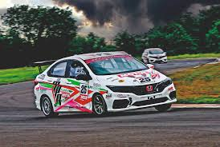

Monthly Newsletter



August 2025 Newsletter

Event Recaps
- Midweek Drive 2nd July
Wednesday saw the usual turnout of cars. They went for a bit of a drive around town and ended up at the Commonwealth Hotel Café for morning tea. As usual the Commie didn’t disappoint with reasonably prices fares and excellent service.
- Monthly Meeting – 8th July
About a dozen of us made the effort to attend the monthly meeting. We discussed various topics ranging from expected date of club shirts to car display at the Townsville Swap Meet and The Driving Together program at the track. All in all an informative night, a few jokes and a couple of beers!
- Monthly Drive – 13th July
We had an early start for our drive this month. Not too early but early enough. A small turnout of around a dozen people saw us all drive down to Brandon to the Little Leaves Garden Centre/Café. What followed was hot coffee, snacks and much chatter! (Forgot to get photo’s again!!).
- Midweek Drive – 16th July
Drive was attended by the usual misfits and after their drive ended up at Bright Eyes Café, Harold Street, West End. New owners more than accommodating and this venue is highly recommended.
- Round 5 Cheapa Auto Spares Sprint Series – 19th July
We had in fact thought we would cancel the event due to the lack of entrants, but because of the number of first timers we bit the bullet and held the event. We had 15 entrants…. just…. some had to pull out due to car failure, and we had a late entry of a beautiful cobra.
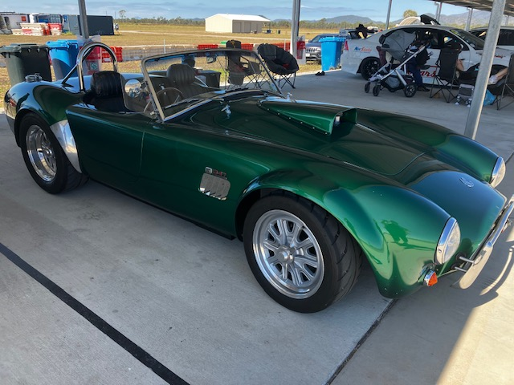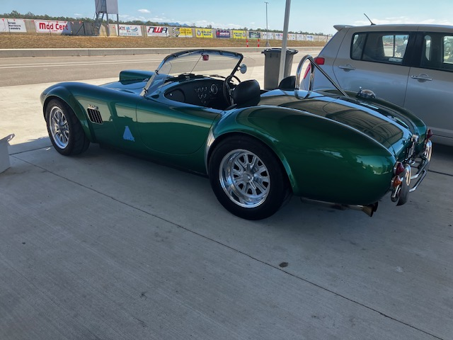

Report from Michael below along with the results.
- Monthly Dinner – 24th July
Was at Bayview Bar & Bistro. We had about a dozen turn up and our table was inside next to a couple of tables with families which made for a lot of noise. Chat was therefore a bit hindered but still enjoyable. The food, whilst lovely, was overpriced (in our opinion) and not a great deal of variety. They do have a great selection of seafood though and a platter for 2 @ $185.00!
- Car Display @ Townsville Swap Meet – 27th July

The weather was very threatening, and we did have a bit of a spit but overall, it was a very nice day to be displaying your car! In other words – NOT TOO HOT! We had 12 cars turn up to display which saw a variety of cars from Dennis’ MGTD, Lionel’s Cobra, Warren’s Datsun 240Z and one that I have not seen before, Gerard’s HK Monaro (which is a real gem!). As usual I didn’t manage to get a photo, so this lady had better pull her socks up for next month!!

- Midweek Drive 30.7.25

The usual crowd had a lovely drive around town and ended up at Bright Eyes Café for morning tea and a natter which I presume involved a lot of talk about cars.

Upcoming Events – August 2025
- 7 August: Club Dinner/Meeting
- 10 August : Monthly Club Drive – Details TBA
- 13 August: Mid-Week Drive – 9:00 AM, WildCatz
- 23 August: Sprint Series Round 6 – Manton Park (DriveIt)
- 27 August: Mid-Week Drive – 9:00 AM, WildCatz

SUNDAY | MONDAY | TUESDAY | WEDNESDAY | THURSDAY | FRIDAY | SATURDAY
31 |  |  |  |  | 1 | 2
3 | 4 | 5 | 6 | 7  CLUB DINNER/MEETING | 8 | 9
10  CLUB DRIVE | 11 | 12 | 13  MID WEEK DRIVE | 14 | 15 | 16
17 | 18 | 19 | 20 | 21 | 22 | 23  SPRINTS RD 6
24 | 25 | 26 | 27  MID WEEK DRIVE | 28 | 29 | 30

FNQ Chapter
Weekly drives meet at 9:00 AM every Wednesday at the Tolga Pub. Recent destinations include the Gillies Roadhouse.
Weekly Sunday Drives
Meet every Sunday at 9:00 AM at Sk8way for a casual, destination-decided-on-the-day drive. All SIV drivers welcome!

Motorsport Highlights – August 2025

- 29-31 August: HSRCA's 2025 Spring Festival will be held at the revived One Raceway circuit in Goulburn
- 8-10 August: Century Batteries Ipswich Super 440 at Queensland Raceway
- 29-31 August: 2025 HQ Nationals and Motorsports Australia Trophy Tour Round 6 at Sydney Motorsport Park
- 16 August: MSCA All British Day at Winton Motor Raceway

From the President

CHEAPA AUTO SPARES SPRINT SERIES – ROUND 5 - JULY 19TH, 2025
Well, what to say. Numbers poor, but racing was great as always.
1st outright - Marty Tears, what can we say. Great win and the car is starting to look great on the track. All the development work being done on the car is definitely showing results. To improve on his lap time of 126.2 is going to be a challenge, with no more easy improvements available from here in. It was good to see a WRX take a win, it has been a long time.
2nd outright - Steve Gurney, V8 Commodore. I would like to welcome him and his lovely wife Jamie back to the racing, along with the now 15-month-old small human monster, who was showing off and winning hearts everywhere. Yeh great drive, but Georgia was well truly the showstopper, reducing your paltry effort of 2nd outright and 1st in class to insignificance.
3rd - Ashley Brooke in the I30N. Great run, great time, but I had his Mum in the RACE X Camaro on the weekend, and I think she could compete with him. Great run mate.
4th outright - Andrew Campbell in his rear-wheel-drive WRX. Bit weird but ok. Seems to have sorted out the demons and times were very competitive. 2nd in class is a great result, and I think times will continue to fall.
5th outright – Ross Reynolds, I30N. Andrew Fisher from Jesus Racing showed up unexpectedly. After walking around the pits chatting with many, I arranged with Ross to take Andrew for a drive and then do a passenger run with Andrew. What a session, by running around with Andrew, Ross was able to improve his time by 2.5 seconds. WOW. Ross was very impressed with how Andrew drove his car, and obviously paid attention to what was being done. A gain like that, nothing but gold.
6th outright – Sasha Packham. 1:29.9 lap time is now only 2 seconds away from beating dad Shaun, at which point she will then own the Skyline. I am thinking some coaching may be in order, to get Sasha her new car sooner rather than later.
7th outright – yours truly. What can I say, unable to get a flying lap in due to overheating issues. We are working on it, and I think new radiators will be required. I did however get to experience the F1 driver following the pace car experience. Andrew Kearney was peddling his guts out in the V6 Commodore whilst I casually cruised along behind him. I did think about razing him over the 2 way but did not as I was concerned razing would be taken seriously.
8th outright - Jamie Gurney. Unlike husband Steve, she did not pale to insignificance due to baby Georgia. It was good to see them both back at the track racing.
9th outright – Michael Ellis-Doidge, V6 Commodore Ute. First time at our event, went well. 1:40.9 is a good lap time, now the serious work starts on learning and improving. Michael had lots of fun, smiled all day and was a pleasure to talk with.
10th Outright, Andrew Kearney, V6 Commodore. Andrew peddled hard all weekend, which I can attest to whilst I followed him for a lap and a half. The Commodore was pushed to its limit
11th Outright, Brian Flemming, AC Cobra Replica. Started out very cautiously, being his first time on a racetrack. Made large improvements over the day, picking up over 10 seconds. Once again, a first timer who had a whale of a time and finally got to drive his Cobra in a much more serious manner than possible when on the road.
12thOutright, Liam MacDonald, Toyota Corolla. 1st in class, budget race car. I love to see racers like this. Out having fun racing his mate in the same car and getting one up on Flynn, beating him by 1.3 seconds. It is on now.
13th outright, Dane Beazley, Toyota Corolla. 2nd in class behind Liam, the challenge has now been issued. Dane is going to have to work on catching his partner in crime in the Corolla. I am going to enjoy watching them.
14th outright, Flynn Kearney, V6 Commodore. Flynn was only 1.8 seconds behind his Dad, so should feel comfortable that the time will not be too hard to catch the old man. Challenge is on. Flynn also improved dramatically through the day.
In all, small field but a good day held by all. Several best times, at least 1 not so good time, and all enjoyed the event. Looking forward to a larger field in August, with the 23rd being the date for round 6.
See you there
Michael
Cheapa Auto Spares Sprint Series – Round 5
NAME | CLASS | BEST TIME
Marty Teare | 5 | 01:26.2
Stephen Gurney | 6 | 01:28.5
Ashley Brooke | 4 | 01:28.8
Andrew Campbell | 4 | 01:29.2
Daniel (Ross) Reynolds | 4 | 01:29.8
Sasha Packham | 4 | 01:29.9
Michael Seymour | 4 | 01:31.0
Jamie Gurney | 6 | 01:37.9
Michael Ellis-Doidge | 4 | 01:38.9
Andrew Kearney | 4 | 01:40.9
Brian Flemming | 6 | 01:41.4
Liam MacDonald | 3 | 01:41.4
Dane Beazley | 3 | 01:41.8

****WANTED****
We are chasing any photo’s or video’s you may have of your car/racing car to put on our website. Any photo’s appreciated.
🏁 Jokes of the Month
Why don’t cars ever get tired?
Because they always rev up their engines! 😄
Why don’t race cars ever get lost?
They always stay on track.
🧠 Fun Fact
The first muscle car:
The 1964 Pontiac GTO is widely considered the first muscle car, though it faced competition from other manufacturers like Ford with the Mustang.
Fuel efficiency:
While some vintage cars are known for their power, many were designed with fuel economy in mind.
The first electric car:
An early electric car was built by Scottish inventor Robert Anderson between 1832 and 1839.
JULY RAFFLE WINNERS
$25 Ampol Fuel Card - Karen Bell
1Kg Fire Extinguisher – Michael Seymour
CONGRATULATIONS TO YOU BOTH! ENJOY!

📣 Got a Story to Share?
We're keen to feature your stories in upcoming newsletters! Whether it’s about your car, a rebuild journey, a favourite road trip, or even a spotlight on a fellow member—send it through. We'd love a few photos too.
We’re also starting a Member Spotlight section to introduce the people behind the cars. Share a short bio, how you got involved with the club, or a memorable motoring moment.
Send your contributions to Michele at: social@marquenq.com.au
(Don’t be shy—we’re still waiting… crickets chirping) 🦗😉

OUR PLATINUM SPONSOR IS:



REMEMBER TO SUPPORT THOSE THAT SUPPORT US.
LET THEM KNOW YOU ARE WITH THE MSCRNQ TO
RECEIVE A DISCOUNT!

