

Monthly Newsletter



September 2025 Newsletter

Event Recaps
- Club Dinner/Meeting – 7 August
We had a great turn up at the Cowboys Leagues Club. The food and drinks flowed. We also were able to say Hi to our lifetime member Wilf Hardy who has moved interstate but visits us when he can. Wilf has been a member of the club since 2000 or thereabouts. As always it was lovely to see him and his wife and we will miss their visits.
- Mid-Week Drive – 13 August
A great drive around town followed by morning tea at Dose Tropical Coffee. We had a good turn out as usual, and I would recommend the coffee shop.
- Monthly Drive – 17 August
We had a drive to Ayr and went to the RSL for lunch. Healthy turnout of about 20 which was great to see. The food was top notch, and I did not hear any complaints from anyone. The drive enabled a few to give their vehicles a good run. We had run a small raffle “lucky square” and sold the last of them at lunch. We drew the winners who were: First Prize – Ray Scagliotti, Second Prize – Alan Stibbs and Third Prize – Evonne Skimmings. Thank you to all for your continued support.
- Super Cheap Auto Sprint Round 6 – 23 August

Great day of racing had by all. Results and report from Michael below.

- Mid-Week Drive – 27 August
A dozen or so cars turned up for the drive out to Bushland Beach. A lovely day weatherwise followed by a great morning tea at Hyve Café. Morning tea was filled with a lot of chat as usual.

Club Announcement

We have club caps for sale $24.00 each. If you would like to purchase one just contact me via email: social@marquenq.com.au. We have also completed the first run of our club polos, but should there be any interest for either a short/long sleeved polo or a black racing T – let me know and we will see what we can organize. All polos and T’s have a minimum order amount so we would need a few people to be interested before we can do another run.

Article by Warren Skimmings
I have been asked by Michele to write an article for our monthly club newsletter. Our club – the Marque Sports Car Register was established to accommodate any make or model car and is now over 30 years old. In that time, we have had some very special cars that most people know little about and each month I will put forward one car from this club as the most notable of that make.
I have organized many car shows for this club and been to way too many very large shows [one with 600 cars], even as a judge, up to National level importance all over the country from North Queensland all the way to Tasmania. With that experience I may be part qualified to select a car from this club each month as the best in Nth. Qld.
This month my selection is Gerard Tarlington’s 1969 Holden HK GTS Monaro – the best HK Monaro I have ever seen.
Gerards’ Monaro restoration is a long story as he started it many years ago in1976 and then sat apart in storage in Canberra until in 2012 when he retrieved it and trailered to Townsville to complete.
It now rarely comes out of its garage, but he and his lovely wife Bernadette brought it along to our little gathering at the recent Swap Meet at the show grounds. It is most notable for its original perfect interior trim, the original 307V8 presented in show standard, and the superb original colour paintwork and bodywork attended to by David Taylor. It has been airconditioned with the cold air being ducted through the beautifully crafted vents in the interior front foot well panels.
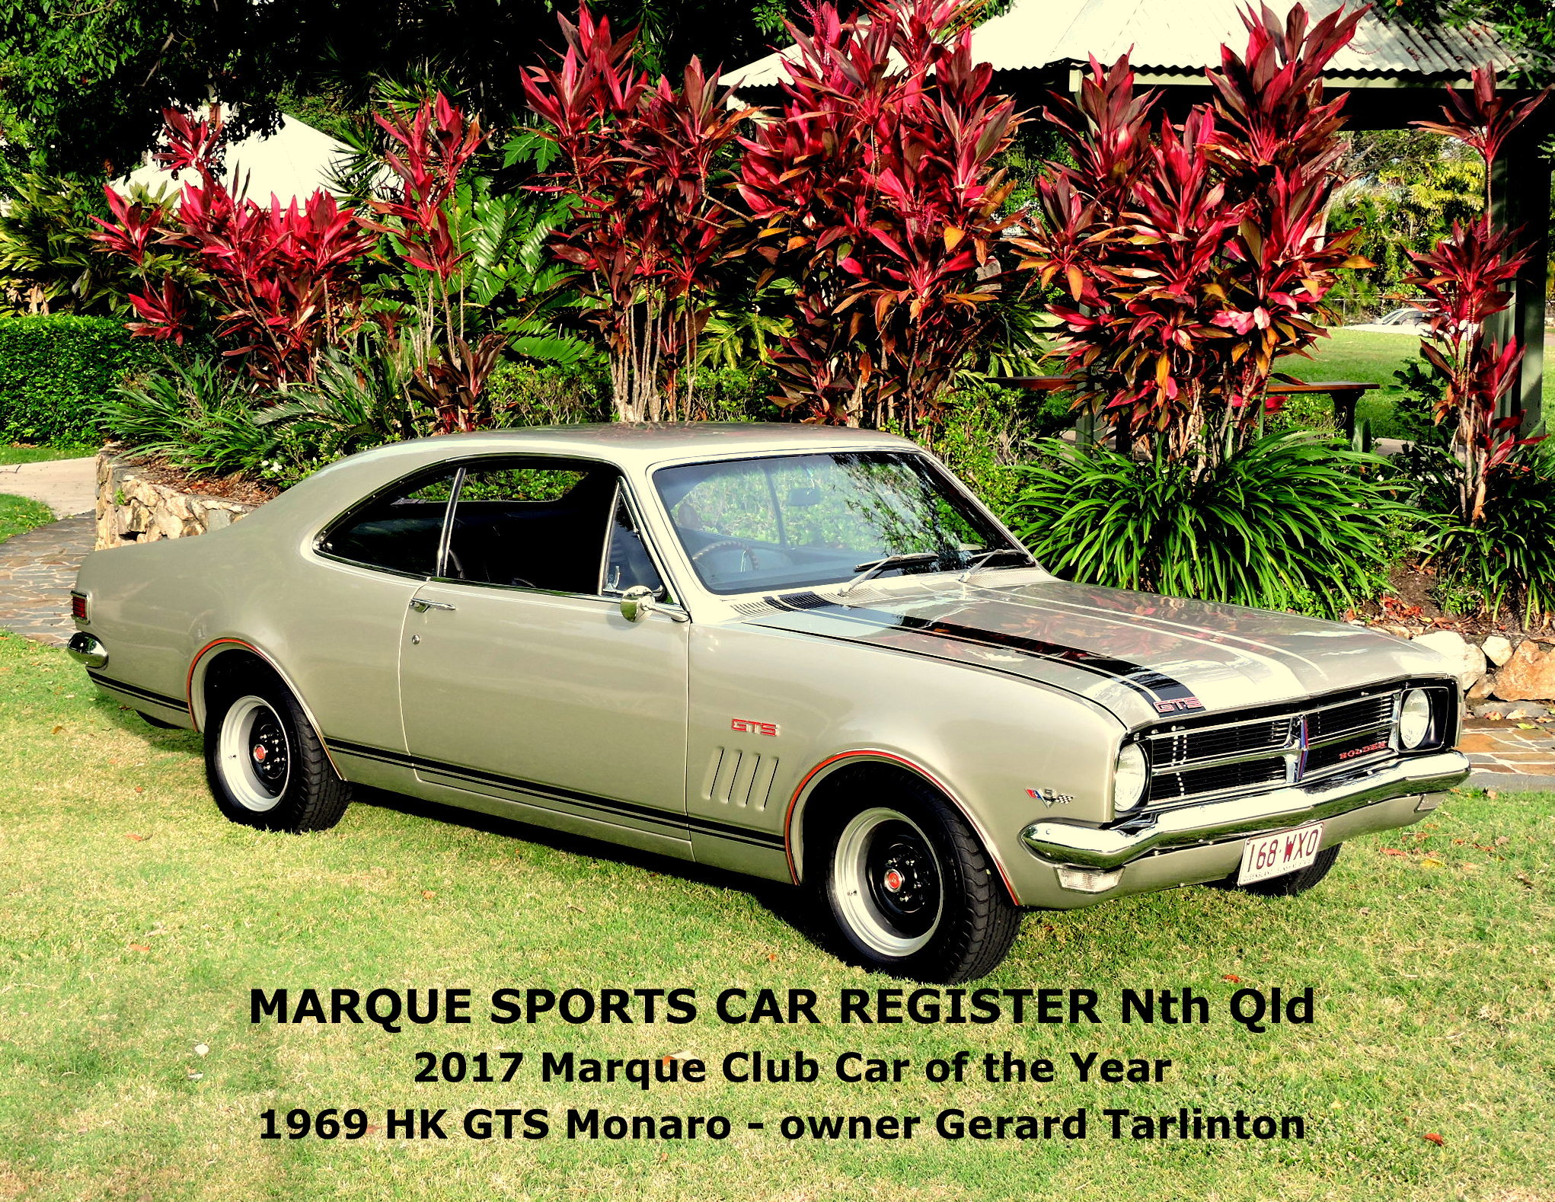
Photo by Skimmo obviously 2017

Upcoming Events – September 2025
- 6 September: Monthly Club Drive – Details TBA
- 9 September: Monthly Meeting – 7:30 PM, Rodders Club House
- 10 September: Mid-Week Drive – 9:00 AM, WildCatz
- 20 September: Sprint Series Round 7 – Manton Park (DriveIt)
- 24 September: Mid-Week Drive – 9:00 AM, WildCatz
- 30 September: Club Dinner – Venue TBA

SUNDAY | MONDAY | TUESDAY | WEDNESDAY | THURSDAY | FRIDAY | SATURDAY
 | 1 | 2 | 3 | 4 | 5 | 6  CLUB DRIVE
7 | 8 | 9  CLUB MEETING | 10  MID WEEK DRIVE | 11 | 12 | 13
14 | 15 | 16 | 17 | 18 | 19 | 20  ROUND 7 SPRINTS
21 | 22 | 23 | 24  MID WEEK DRIVE | 25 | 26 | 27
28 | 29 | 30  CLUB DINNER

FNQ Chapter
Weekly drives meet at 9:00 AM every Wednesday at the Tolga Pub. Recent destinations include the Gillies Roadhouse.

Weekly Sunday Drives
Meet every Sunday at 9:00 AM at Sk8way for a casual, destination-decided-on-the-day drive. All SIV drivers welcome!

Motorsport Highlights – September 2025
- 25 September 2025 - QRDC
- 14 September 2025 GT racing.
- 6 - 7 September 2025 Super Bike Championship Phillip Island
- 5 - 7 September 2025 GT World Challenge The Bend, Australia

From the President
Cheapa Auto Spares Sprint Series – Round 6
Great to see another 29-car field this time. And boy, there were some great cars. The West WX10 was back, along with Keelan Dunstan’s Ginetta, newly imported from England. The Porsche Cayman GT3RS was back as was Gary Browns C8 Corvette.
Class 2
Poor Cameron Brown was really up against it in his Suzuki Swift. Chasing the West, well there was only 1 chance of beating it, the shortcut from turn 2 to turn 9. He did not try it, but still managed a 1:34, which for a normal class 2 is a great time. Maybe it is time to set up class 8 again.
Class 3
Silvano was first in class for the first time, well done mate. Ian Jorgenson in the mighty Fiat 500 Abarth was a mere 1.3 seconds back. Amazing result for the pocket rocket.
Class 4
Keelan’s Ginetta dominated class 4. 3.8 seconds in front of Brett Twyford’s GT3RS, wow. The Porsche is one hell of a weapon, but it shows what a proper GT3 race car is capable of. Third in class was Tim Branch in his Mitsubishi Starion, with a phenomenal 1:23 lap. Just amazing for a car from the 80’s. Anthony Villella kept up his great results in the Honda Civic. Steve McHugh was 2 seconds back, and 2 seconds clear of a group clustered behind him, Edward Deren, Ross Reynolds and an unlucky Shane Corradi (exhaust nuts fell off), with the last 4 in class, Andrew Kearney, Flynn Kearney, Michael Ellise-Doidge and Bradley Gilroy keeping all in front of them honest.
Class 5
Leo Rodriguez took out class 5 with Blake Joppich and Flynn Dunkerton taking out 2nd and 3rd respectively. Justin Brittian was 4th and Brodie Rose in 5th. Leo was only a second quicker than Blake, whilst Flynn was a tenth of a second in front of Justin.
Class 6
Gary Brown, in the now broken C8 Corvette, won class 6, with Lloyd Struber once again performing miracles in his XR8 Falcon. Earlier this year Lloyd did a 1:25, which he topped once again with a 1:24.7. Very, very cool. 3rd in class was Michael Cutuli in his LS powered BMW, with first timers following in 4th, 5th and 6th. John Sinclair and Marty Grogan followed along in the Mustang, but my drive of the day went to Kelsey Brown. First time on a racetrack, driving her dad’s C8 Corvette, great job Kelsey. Oh yeh, and dad was driving the C8 when it broke, so we can claim it was his fault.
OUTRIGHT
Phil Moravcik was fast, real fast. Only 1.4 seconds off the lap record on only his second drive in the West is superb, However, I think Keelan Dunstan will have a say on who will get the new lap record first. If Keelan had not blown an oil filter, I think it would have been even closer. Brett Twyford and Gary Brown were their usual quick selves, with the amazing runs of Tim Branch and Lloyd Struber running in 5th and 6th, with Michael Cutuli, Leo Rodriguez, Anthony Villella and Blake Joppich rounding out the top 10. 4 of the 5 classes were represented in the top 10, which just shows the diversity of quick cars we have on track.
A great day, with good numbers. 29 cars, many laps as usual, some very quick times, amazing cars and great people. I want to thank all who ran. You make the officials jobs easy, and it is a pleasure watching all go around. Don’t get caught up in the outright runners, improving your time is all you should worry about.
Zeds Rule
Michael Seymour

NAME & CLASS | CLASS | TIME
Phil Moravcik | 2 | 1:16.574
Keelan Dunston | 4 | 1:17.785
Brett Twyford | 4 | 1:21.644
Gary Brown | 6 | 1:22.007
Tim Branch | 4 | 1:23.089
Lloyd Struber | 6 | 1:24.724
Michael Cutuli | 6 | 1:24.992
Leo Rodriguez | 5 | 1:25.475
Anthony Villella | 4 | 1:25.887
Blake Joppich | 5 | 1:26.590
Steve McHugh | 4 | 1:27.869
Edward Deren | 4 | 1:29.164
John Sinclair | 6 | 1:29.418
Daniel (Ross) Reynolds | 4 | 1:30.175
Shane Corradi | 4 | 1:31.062
Flynn Dunkerton | 5 | 1:31.850
Justin Brittain | 5 | 1:31.929
Silvano Nobile | 3 | 1:32.767
Marty Grogan | 6 | 1:33.539
Cameron Brown | 2 | 1:34.058
Ian Jorgensen | 3 | 1:34.068
Andrew Kearney | 4 | 1:36.312
Kelsey Brown | 6 | 1:36.854
Brodie Rose / Boase | 5 | 1:37.384
Flynn Kearney | 4 | 1:37.607
Jeff Fussell | 6 | 1:37.966
Michael Ellis-Doidge | 4 | 1:38.715
Stephen Huggan | 6 | 1:39.613
Bradley Gilroy | 4 | 1:39.909
Phil Moravcik | 2 | 1:16.574

🏁 Jokes of the Month
I renewed my car insurance over the phone today, and as I was about to hang up the woman on the other end asked if I had a pet. I said, “Yes, I’ve got a dog.” She asked, “Would you like to insure him too?” I said, “No thanks, he can’t drive!” 😄
Dad is down at the car dealership, looking at potential choices. “Cargo space?” he asks. The salesman says: “Car no do that. Car go road.”
🧠 Fun Fact
The first full-scale, self-propelled mechanical vehicle was released in 1769. It was a steam-powered tricycle that was used to haul cannons around town. (But, it weighed 8,000 pounds!)
The 1964 Pontiac GTO is widely regarded as the first “muscle car.” Pontiac owned the muscle scene in the early 1960s, but by 1968, that car had plenty of competition.
The most expensive car ever sold at a public auction was a 1954 Mercedes-Benz W196R Formula 1 race-car. In 2013, it went for a staggering $30 million.

📣 Got a Story to Share?
We're keen to feature your stories in upcoming newsletters! Whether it’s about your car, a rebuild journey, a favourite road trip, or even a spotlight on a fellow member—send it through. We'd love a few photos too.
We’re also starting a Member Spotlight section to introduce the people behind the cars. Share a short bio, how you got involved with the club, or a memorable motoring moment.
Send your contributions to Michele at: social@marquenq.com.au
(Don’t be shy—we’re still waiting… crickets chirping) 🦗😉

OUR PLATINUM SPONSOR IS:



REMEMBER TO SUPPORT THOSE THAT SUPPORT US.
LET THEM KNOW YOU ARE WITH THE MSCRNQ TO
RECEIVE A DISCOUNT!

