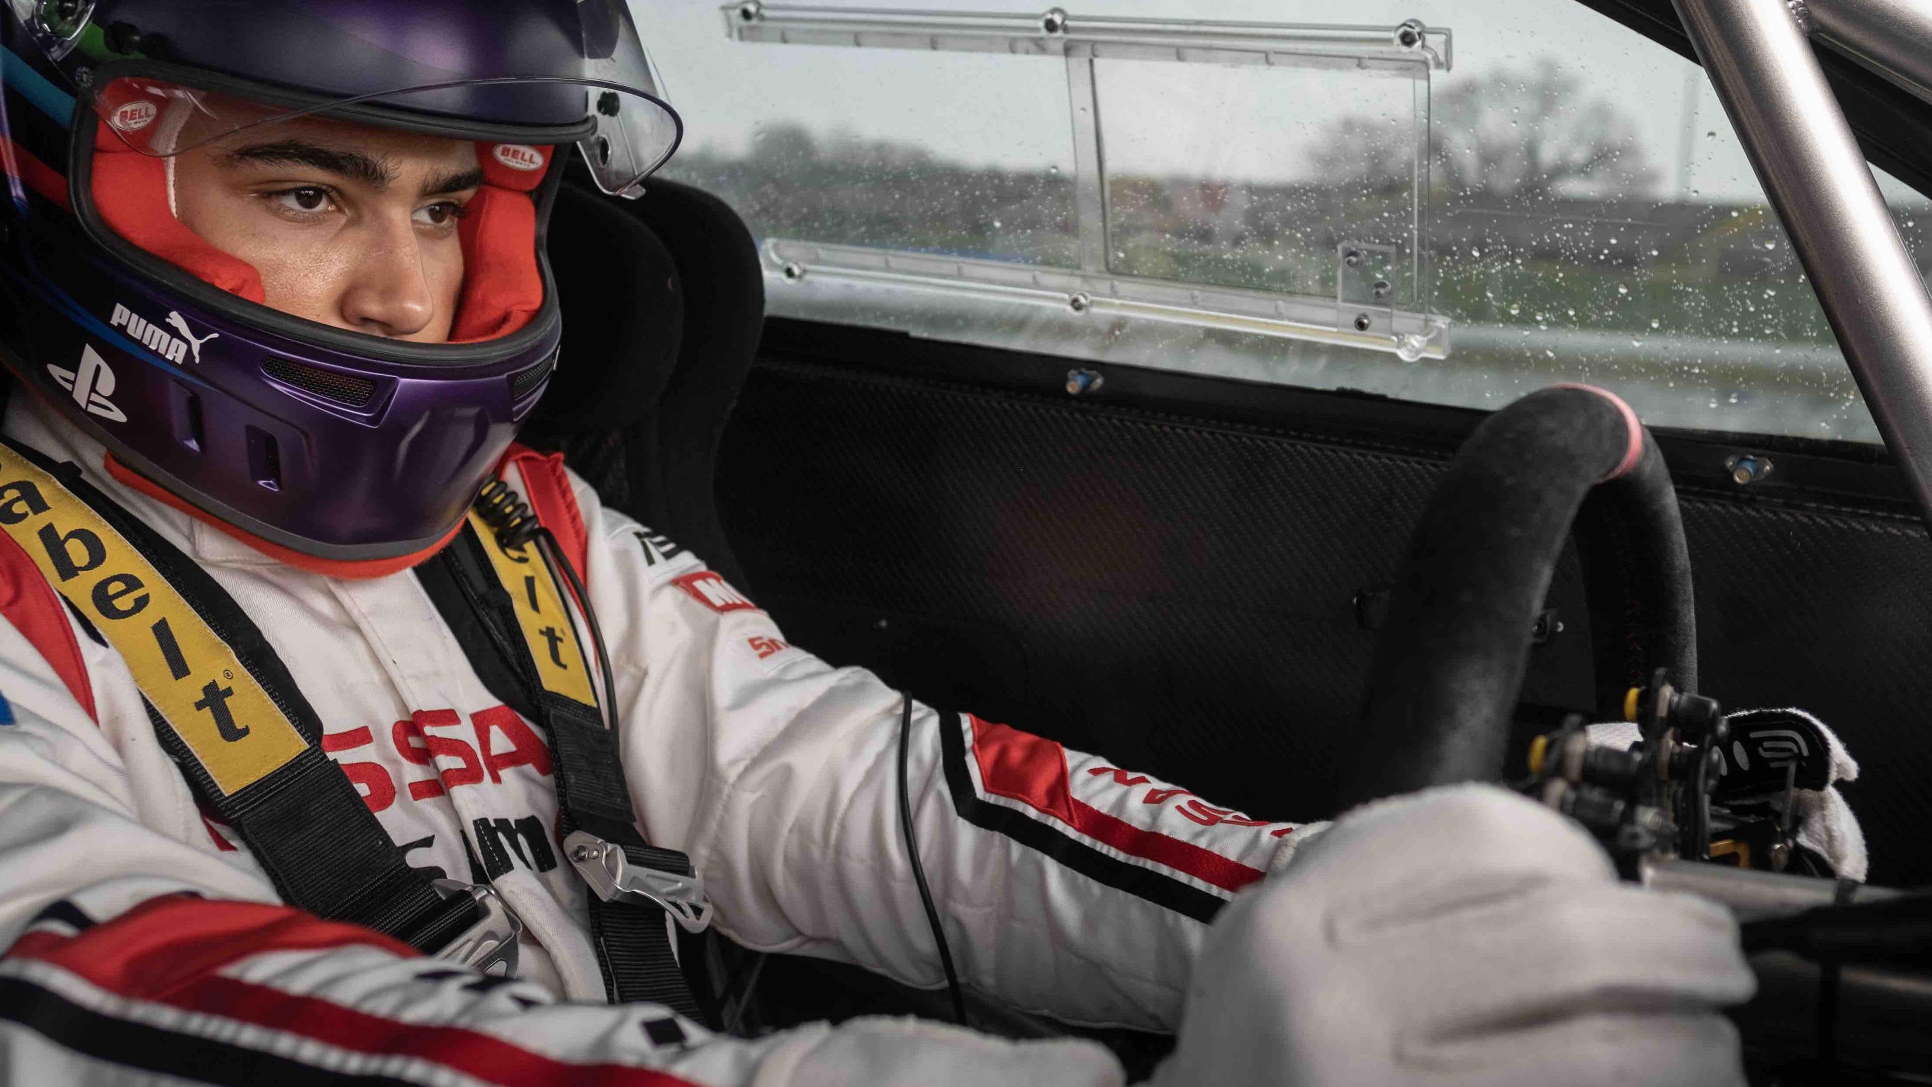

Monthly Newsletter



October 2025 Newsletter

Event Recaps
- Club Drive – 6th September
There were about 20 of us that went for a lovely drive to Charters Towers. The TD was a bit reluctant to go but once we finally started it there was no stopping it. Dennis really knows how to keep it moving. We went to the Commercial Hotel for lunch. The food was great and not overly expensive. We ran a couple of raffles: Lucky Square 1st prize of $10 was won by Jill, second prize $5 won by Evonne and finally 3rd prize of $3 won by Jeff. The big raffle of a $25 BWS gift card was won by Alan and will go towards his next bottle of rum! After lunch some headed off to one of the museums for a gander, some headed to Proserpine for dinner, and the rest of us had a leisurely drive home.
- Club Meeting – 9th September
The usual turned up to the meeting and we had a lively discussion about all things racing, shirt orders and the annual Christmas Party.
- Mid Week Drive – 10th September
Marina Café was the destination for this drive, and the numbers were down for this one. Morning tea was fantastic, and I am sure the conversation consisted of a lot of car talk.
- Round 7 Cheapa Auto Spares Sprint Event – 20th September
What a fantastic turnout we had 33 sprinters on the day. Lots of hustle and bustle and a great day of racing. Report by the President below with results.
- Mid Week Drive – 24th September
Destination for this drive was Dirty Boots Café – which we had been told was open again. Everyone arrived there to find that it was closed so decided to go to Banjo’s Café where the food and coffee flowed and so did the bullsh*t – sorry, I mean talk about cars!
- Club Dinner – 30th September
Metropole Hotel – well what a great venue. Beautiful décor and fantastic service. They had us at a high table and when we asked to be moved, they were very obliging and gathered all the tables up and put us at a long low table. The food was great and was served in a timely manner. We would highly recommend the Metropole to anyone. We had a wonderful evening and lots of chatter. We sold some more raffle tickets (sold some at the track previously) and drew the winner – number 98 who was “Sasha Packham”. Sasha tells me she is going to use the Bundy for rum balls – wink, wink!

Club Announcement


The club is holding their annual Christmas Party on Saturday 29th November. We have hired the Range Room at Brothers Leagues Club. The meal will be a buffet of: Roast Beef, Country Style Roasted Lemon & Tarragon Chicken, Balinese Barramundi Coconut Curry and twice cooked Asian pork belly. Salads, rice and vegetables will accompany the mains followed by dessert and tea/coffee. So why not get festive, bring your appetite and get ready to jingle all the way.
We will have lucky door prizes, raffles and even a members draw – you must be there to win it! Best dressed (Xmas theme) will also win a prize.
All this for a mere $28.00/head with the club subsidizing the balance. Please support your club and come along for a wonderful night. RSVP to Michele: social@marquenq.com.au or text 0429 788 362 or respond via the website: https://marquenq.com.au/event/presentation-night


We have club caps for sale for $24.00 each. We have also had some enquiries about short sleeve polo’s. So we are putting in a second order. If anyone would now like to order a short sleeve polo $49.00 – just let me know: social@marquenq.com.au or text: 0429 788 362. We are also ordering the black cotton racing T’s - $33.00. We have also had someone enquire about white cotton racing T’s (which will be the same price) but we need an order of 10 minimum so if someone out there loves their black racing T and would also like a white one – let us know. I reckon they would make a great T shirt to wear out!
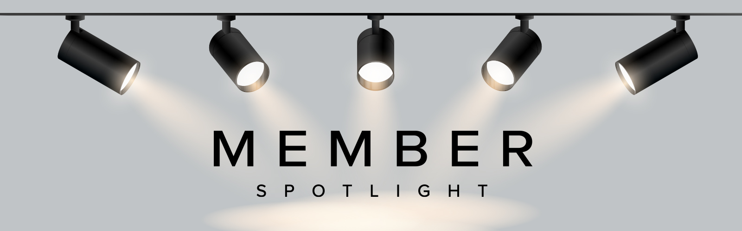
FEATURE CAR - LANCIA Fulvia
Submitted & written by Warren Skimmings
This month’s feature car was owned by Chris and Nerolie Mills who went through a long restoration project to salvage/restore this very rare little car in Townsville. It is a RHD 1960s Lancia Fulvia that has been restored back to it’s original concept of a lightweight World Rally Car.
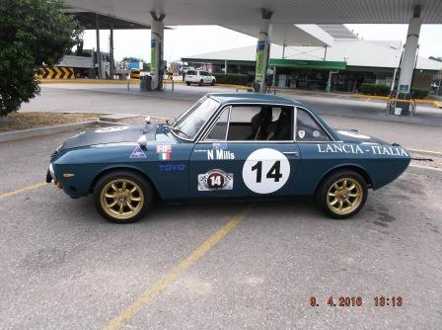
Despite almost buying one of these when I was in the used car business back in 1977. I had traded one in on a new car and drove it around for about a month. But with my limited contact with one of these I still needed a lot more detail on this car and Chris wrote the background (below) on this fantastic finished project:
“LANCIA FULVIA 1.2s
Derived from the Fulvia sedan, Lancia's pretty little Fulvia coupe was one of the more sophisticated Italian sports cars of the 1960s. With deceptively understated styling, the elegant Fulvia was designed under the direction of Pietro Castagnero and introduced to the market in 1965. Like its sedan sibling, the Fulvia coupe was powered by a narrow-angle V4 with a single-overhead camshaft and drive was through the front wheels. Early Fulvia variants used a 1.2-litre engine but as the model progressed more power was called for and the ultimate version was the 1.6-litre HF, with twin Solex carburetors and 115bhp on tap.
With superb handling and ride, sharp steering and excellent brakes thanks to discs all round, the Fulvia was a natural candidate for rallying. The Fulvia achieved some fantastic results in the World Rally Championship in the 1960s and early 1970s under the direction of Cesare Fiorio, setting the scene for Lancia's later domination of the sport.
To homologate a number of performance modifications, Lancia came up with the so-called Fanalone (a somewhat crude reference to the size of the larger driving lights), distinguishable from the standard HF by the fiberglass flares on the wheel arches to cover wider Campagnolo rims. Inside, the Fanalone had lightweight bucket seats, and the rear seats were replaced by a shelf, while the instrumentation was improved with an oil temperature gauge and adjustable red-line on the tacho.
In total just 1,280 Fulvia HF1600s were built to this specification in 1968-1969 and few were sold in right-hand drive markets due to the prohibitive asking price.
Today, these homologation specials are recognized by Lancia afficionados as the jewels in the Fulvia crown, beautifully engineered, understated yet to those in the know, utterly desirable.”
There are other project cars done by Chris and Nerolie. Just from my memory the next one after the Lancia was a Lotus Super 7 Clubman. The first photo is of them in the Lotus in its early form and is taken from our Marque Club advertising board when they both raced it very capably at our early Sprint Racing Series at the Shaw Road Kart Track.
The next photo is of this Lotus after they put it through a big tidy up to show car standard with Lotus Team colours and eventually moved it along to another owner. “down south”.
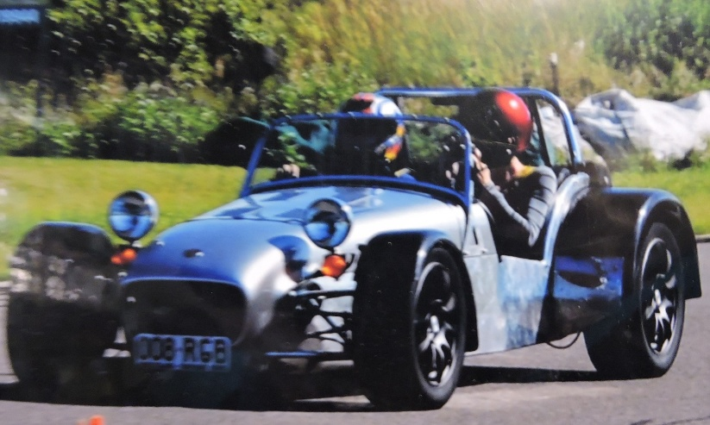

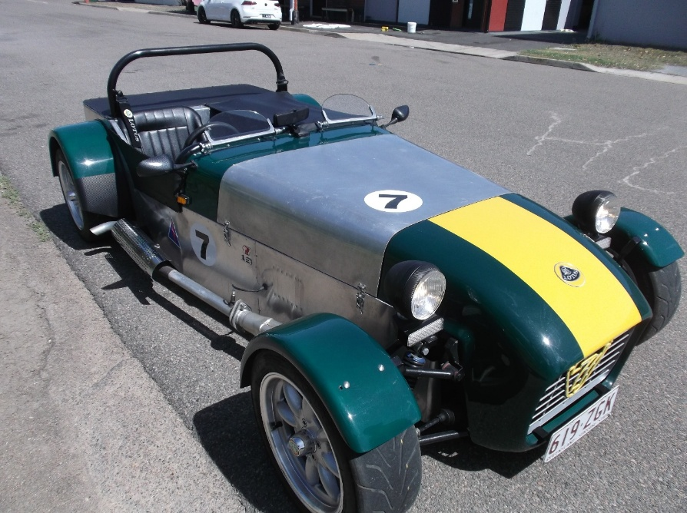

There are other project/restoration cars from this couple. The next one in line from my failing memory is a 1968 [I think] Ford 100. It was an absolute showstopper all finished in period colours “two tone” light green and cream with pin stripping of the era. Sorry I don’t have a photo of this great car.
The next in line is from my “memory” - it is the current one we see occasionally at our drive days. It follows the path of being VERY different from the MILLS COUPLE. All I can say is “Wow – just where did that great idea come from?”
A VW BEETLE UTE
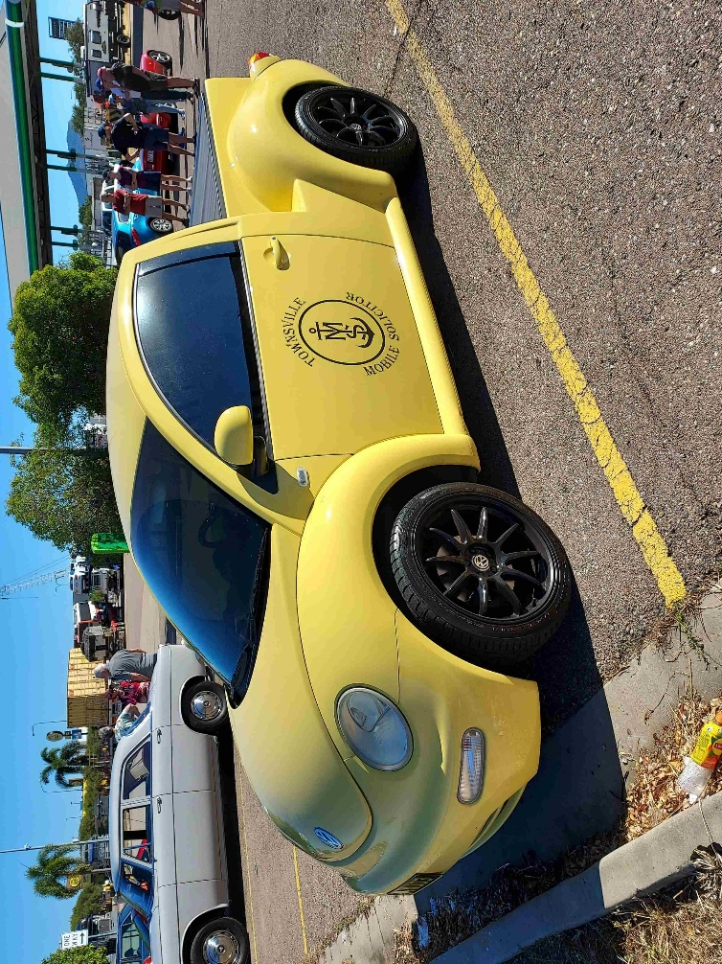
To finish the magazine article on the Mill’s couple’s collection of restored cars I think I should include another very different item to their list. It is a Triumph motorcycle and this one is considered by many as the most revered famous motorcycle in the world. It is the motorcycle ridden by Steve McQueen in the famous Great Escape movie as shown in the attached photo. It has been owned recently by Chris and Nerolie Mills, and I have seen it proudly displayed in their home - right here in Townsville. 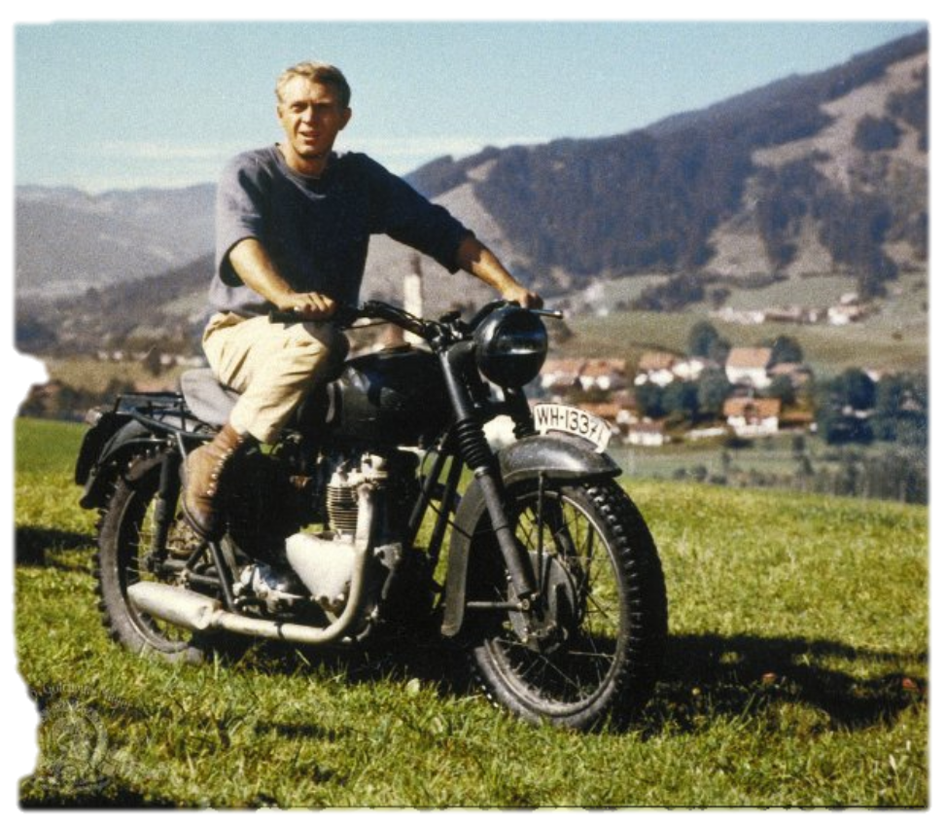
Denise and I have great respect for and trust Chris Mills. He has recently helped us to formulate our last legal paperwork requirement and would strongly recommend him to anyone in our club for most legal advice.

Upcoming Events – October 2025
- 4 October: Club Drive – Dice Run to Commonwealth Hotel for lunch
- 8 October: Mid-Week Drive – 9:00 AM, WildCatz Indoor Sports Arena
- 15 October: Club Dinner/Meeting – Aalishan Indian Restaurant, Palmer Street
- 18 October: Sprint Series Round 8 – Manton Park (DriveIt)
- 22 October: Mid-Week Drive - 9:00 AM, WildCatz Indoor Sports Arena

SUNDAY | MONDAY | TUESDAY | WEDNESDAY | THURSDAY | FRIDAY | SATURDAY
 |  |  | 1 | 2 | 3 | 4  CLUB DRIVE
5 | 6 | 7 | 8  MID WEEK DRIVE | 9 | 10 | 11
12 | 13 | 14 | 15  CLUB DINNER/MEETING | 16 | 17 | 18  ROUND 8 SPRINT SERIES
19 | 20 | 21 | 22  MID WEEK DRIVE | 23 | 24 | 25
26 | 27 | 28 | 29 | 30 | 31

FNQ Chapter
Weekly drives meet at 9:00 AM every Wednesday at the Tolga Pub. Recent destinations include the Gillies Roadhouse.

Weekly Sunday Drives
Meet every Sunday at 9:00 AM at Sk8way for a casual, destination-decided-on-the-day drive. All SIV drivers’ welcome!
We would like to point out here that the weekly Sunday drives are only on the calendar if anyone is interested in taking their car or SIV registered car for a drive. Maybe one or two of you will end up getting together for a drive!

Motorsport Highlights – October 2025
- 9-12 October: Repco Bathurst 1000
- 17-19 October: MotoGP™ Australian Motorcycle Grand Prix at Phillip Island
- 11-2 October: Australian Hillclimb Championship @ The Bend Motorsport Park
- 24-26 October: 2025 Boost Mobile Gold Coast 500

From the President
Cheapa Auto Spares Sprint Series Round 7
CLASS 2
Junior driver Lachlan Parnell had his first drive in our event and finished on a credible 2.02, well done mate. Looking forward to the next event. Liat Talora finished 5th in class, running around in the 1.42 bracket until she went for a run with Leslie Reeves, and went 4 seconds quicker. Another first timer, brilliant result. To keep the first timers going, Stacey Lee in his Excel ran a 1.37 for 4th in class and Phil Wilcox, the second driver in the TECNQ car was 3rd in class. 2nd in class before we get to a previous runner, well done Pat Driscol with Dale Stevenson winning the Excel class, oops, I mean class 2 with a very quick 1:30.23.
CLASS 3
Lily Wicks was 5th in class but was unable to get a proper time in as the Subaru was running poorly. I think Harry James may be in trouble if Lily’s car is not running well next event. 4th was Riley Houston, I think. It does not appear the boys used 2 transponders for the Nissan, so Riley gets the tick. Silvano managed a PB getting down to 1:32.68, which was bettered by Troy Tappenden who also did a PB at 1:30.82. Amos Sinclair finally got a clean run in his Series 1 RX7 and stole first in class late in the day with a lap of 1:30.15. Look out Amos, you now have a target on your back.
CLASS 4
Michael Ellis-Doidge was 10th in class in his Commodore Ute, not the Commodore that abused the cone at the previous event. Sasha Packham 9th, Peter Harben 8th and Shaun Packham in 7th, holding onto bragging rights over Sasha. Shane Corradi was 6th, Tim Branch 5th and Zac Gough 4th. Lindsay Stone was 3rd in class, unable to catch Brett Twyford in the Porsche Cayman GT4 RS. First in class was Keelan Dunstan with a 1:15.2, just 0.1 seconds of the lap record.
CLASS 5
Marty Teare did an amazing lap of 39:20.64. Amazing what a car can do to you. Hope it runs proper next event. 1st in class, Benjamin Brooksby in his Toyota Yaris GR, 1:26.92. Yaris is flying.
CLASS 6
Shana Brown was 5th in class in her first event, with sister Kelsey taking 4th. Gary Brown was 3rd in class, bemoaning the handling of the Falcon v’s the Corvette and the GT40. That will teach him for breaking all his cars. 2nd in class, Paul Frank, with Terry Collins sneaking the class win by 0.011 seconds. Close, but no banana for Paul
OUTRIGHT
As stated earlier, Keelan Dunstan had a great run in his second outing in the Ginetta, doing a 1:15.2, 1 tenth off the lap record. Look out, it is on now. 2nd outright was Brett Twyford in the Porsche and 3rd outright, completing the Class 4 dominance was Lindsay Stone. In fact, Class 4 took out the top 6 spots. The challenge is now on, who can end the Class 4 domination.
Hope all had a great weekend, I know I did. Thanks to my officials and the competitors, with a special mention to the ladies running the BBQ.
See you at round 8 on October 18th.
Zeds Rule
Michael
Cheapa Auto Spares Sprint Series – Round 7 Results
NAME | CLASS | BEST TIME
Keelan Dunston  Brett Twyford  Lindsay Stone  Zac Gough  Tim Branch  Shane Corradi  Benjamin Brooksby  Amos Sinclair  Dale Stevenson  Shaun Packham  Troy Tappenden  Peter Harben  Leslie Reeves  Silvano Nobile  Terry Collins  Paul Frank  Sasha Packham  Gary Brown  Riley Houston  Michael Ellis-Doidge  Jeff Fussell  Patrick Driscoll  Philip Wilcox  Stacy Lee  Liat Talora  Kelsey Brown  Shana Brown  Lachlan Parnell  Lilly Wicks  Marty Teare  Harry James  Jayke Clouten  Simon Howser  Pat Barnett  Terry Frank | CLASS 4  CLASS 4  CLASS 4  CLASS 4  CLASS 4  CLASS 4  CLASS 5  CLASS 3  CLASS 2  CLASS 4  CLASS 3  CLASS 4  CLASS 2  CLASS 3  CLASS 6  CLASS 6  CLASS 4  CLASS 5  CLASS 3  CLASS 4  CLASS 4  CLASS 2  CLASS 2  CLASS 2  CLASS 2  CLASS 5  CLASS 5  CLASS 2  CLASS 3  CLASS 5  CLASS 3  CLASS 2  CLASS 3  CLASS 4  CLASS 6 | 1:15.263  1:21.420  1:23.833  1:23.860  1:24.269  1:26.401  1:26.927  1:30.154  1:30.234  1:30.615  1:30.828  1:31.078  1:31.700  1:32.689  1:32.806  1:32.817  1:32.893  1:33.376  1:35.423  1:36.841  1:36.947  1:37.234  1:37.337  1:37.705  1:38.729  1:39.783  1:54.242  2:02.414  2:02.627  39:20.649

Special Mention
Big shout out goes to Gary Brown – THANK YOU GARY!! Gary had his daughter design and print up some stickers for the club and handed them out to the racers who attended round 7. Don’t they look great – shame we didn’t think of it!
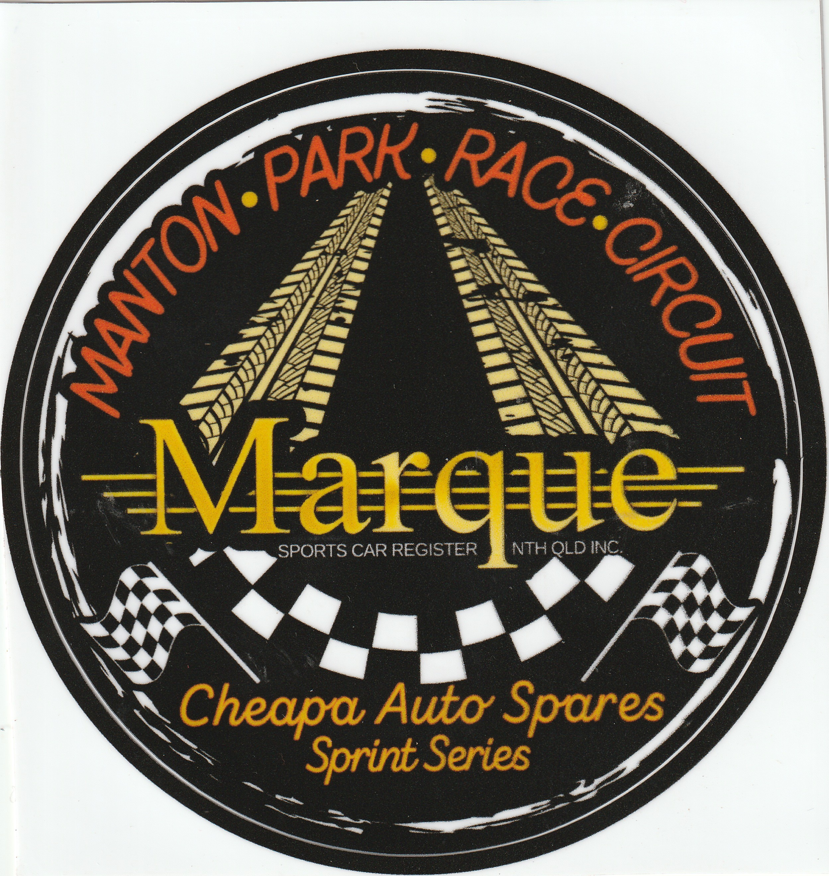
🏁 Joke of the Month
I keep trying to watch racing on my computer, but every time I press the F1 key, it just opens a help window. 😄
Why should Microsoft, Intel, and Nvidia get into the motorsport business?
They already have the best drivers. 😄
Why do DJs make terrible drivers?
They keep changing tracks. 😄
🧠 Fun Fact
Did you know: the world's first petroleum-powered motorcycle, a German wooden prototype called the Reit Wagen, was made in 1885 by Daimler and Maybach.
The first series production motorcycle was the German-made Hildebrand & Wolf Müller from 1894-1897.
The first-ever Harley-Davidson motorcycle used an empty tomato can for its carburetor.
The first bike to exceed 200 mph was a supercharged 499cc NSU in 1956, reaching 211.4 mph.
📣 Got a Story to Share?
We're keen to feature your stories in upcoming newsletters! Whether it’s about your car, a rebuild journey, a favourite road trip, or even a spotlight on a fellow member—send it through. We'd love a few photos too.
As you can see we have a Member Spotlight section to introduce the people behind the cars. Share a short bio, how you got involved with the club, or a memorable motoring moment. Surely, there is someone out there that has a story to tell – don’t be shy!!
Send your contributions to Michele at: social@marquenq.com.au
(Don’t be shy—we’re still waiting… crickets chirping) 🦗😉

OUR PLATINUM SPONSOR IS:



REMEMBER TO SUPPORT THOSE THAT SUPPORT US.
LET THEM KNOW YOU ARE WITH THE MSCRNQ TO
RECEIVE A DISCOUNT!

