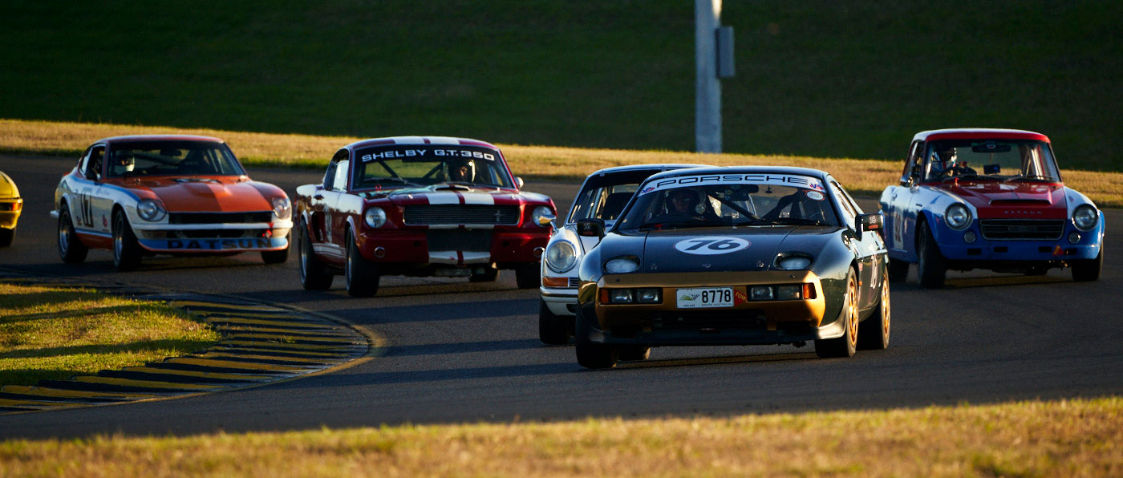

Monthly Newsletter



November 2025 Newsletter

Event Recaps

- October Drive – Saturday 4th October
What a wonderful group that turned up for our Dice Run. 8 of us that played along and rolled the dice – I forgot to bring the dice but lucky for us the “app” store had me covered. We had 6 stops altogether – Wildcatz, RAAF Base, Pallarenda, Bulk Sugar Terminal, Stuart State School and the Commonwealth Hotel. I was the weakest link rolling 59, we had a couple of 65’s but the WINNER WINNER CHICKEN DINNER was Troy Tappenden on 69. Troy took home the $40.00 which covered his entry fee, beer and lunch. CONGRATULATIONS Troy and well done for having some cash!

- Mid-Week Drive – 8th October

Drive around town followed by morning tea at the Commonwealth Hotel – which seems to be a popular venue at the moment.

- Club Dinner/Meeting – 15th October
Aalishan Indian Restaurant. Wonderful night was had by all. The food was great and we all had plenty to eat followed by lots of eating and drinking.
- Round 8 Cheapa Auto Spares Sprint Series – 18th October

Great turn out for this one with 26 entrants who thoroughly enjoyed their day of racing. Results below and report from Club President, Michael.

- Mid-Week Drive – 22nd October

Saw the guys drive to War Hero’s Café at the Woolcock Street Complex. As usual, a great drive around town followed by lots of chat and a great morning tea. Highly recommend this café to all!

Club Announcement:


Come one, come all!! Please support your club. We would like to see as many members as we can support our annual Christmas Party. We will be having a members draw (you need to be there to win it), raffles and door prizes. Prize for the best Christmas costume! Let me know your intention to attend.
Cost to you is $28.00 per head with the club subsidizing the balance. Brothers Leagues Club, Range Room @ 6:00pm. RSVP to Michele:
social@marquenq.com.au or text 0429 788 362 or respond via the website:
https://marquenq.com.au/event/presentation-night

November Feature Article – by Warren Skimmings
The car for this month is the very rare stunning Jaguar XK120C new replica - finished the build in the Queensland Northwest town of Greenvale by our member – Dick Boardman. He had retired from his last paid job in Port Moresby and bought a home in Greenvale for a very quiet existence with plenty of time for his urge to restore a few project cars he had in mind. The top of the list was this Jaguar
With his vast contacts in England – and being a member of most exclusive club in the UK – the British Racing Drivers Club who are part of the Goodwood Classic car event and Silverstone Formula1Race Track - he then contacted the company – “Nostalgia” who had the ability to manufacture a new full aluminum body and new approved chassis for the Jaguar XK120C. They had bought all the molds and chassis drawings from Jaguar who were in some financial difficulties after the very short production run of just 53 Type C Jaguars ever built.
In about 2009 he ordered a new chassis fitted to a new full aluminum body painted the classic British Racing Green along with 6 new wire spoke wheels with race tyres of the era fitted. It was tied down in a shipping container and shipped to Australia and onto Greenvale. It arrived in perfect condition for Dick’s task of finding and fitting all the Jaguar mechanical parts from within Australia. I have seen the invoice just from Nostalgia – my memory has it at about 75.000UK pounds. On top of that was shipping cost. He did tell me that the total finished cost for this car with no labor included was about $250,000 AUD. This club jumped into the final task of assisting with Qld Registration.
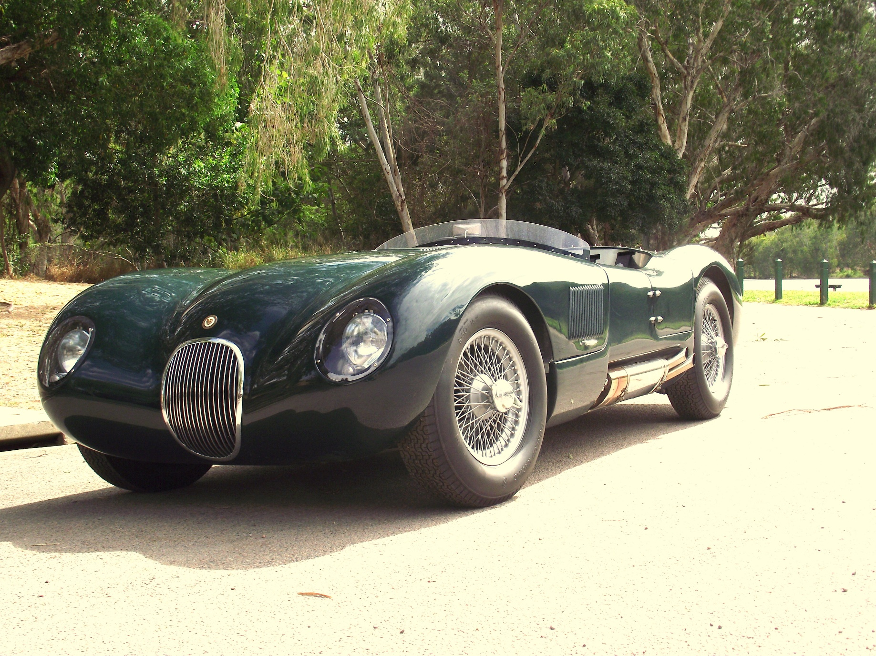
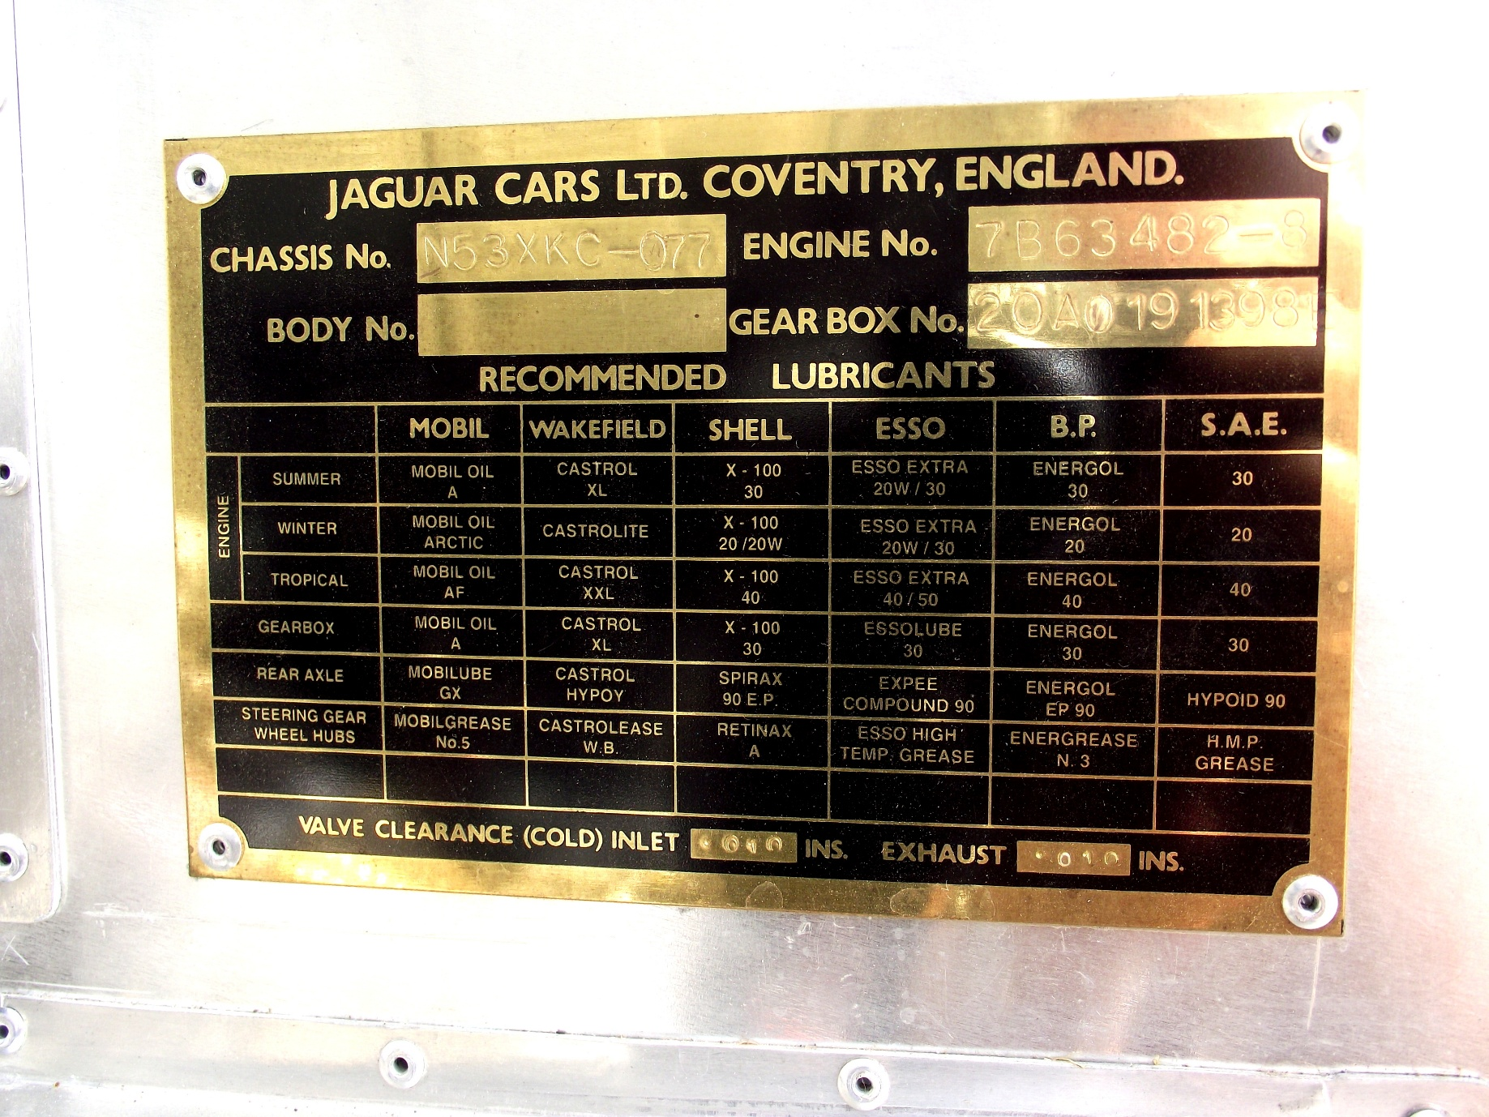
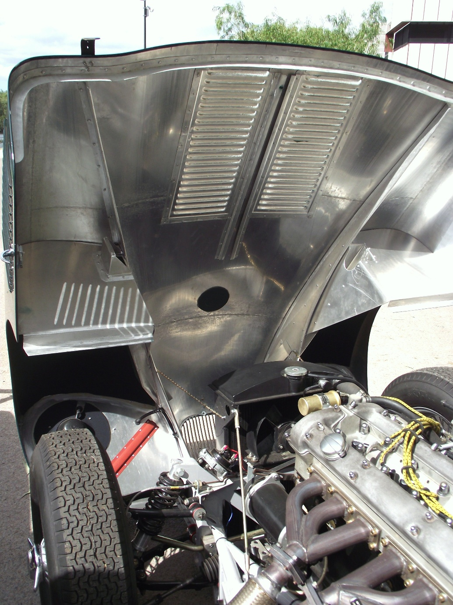

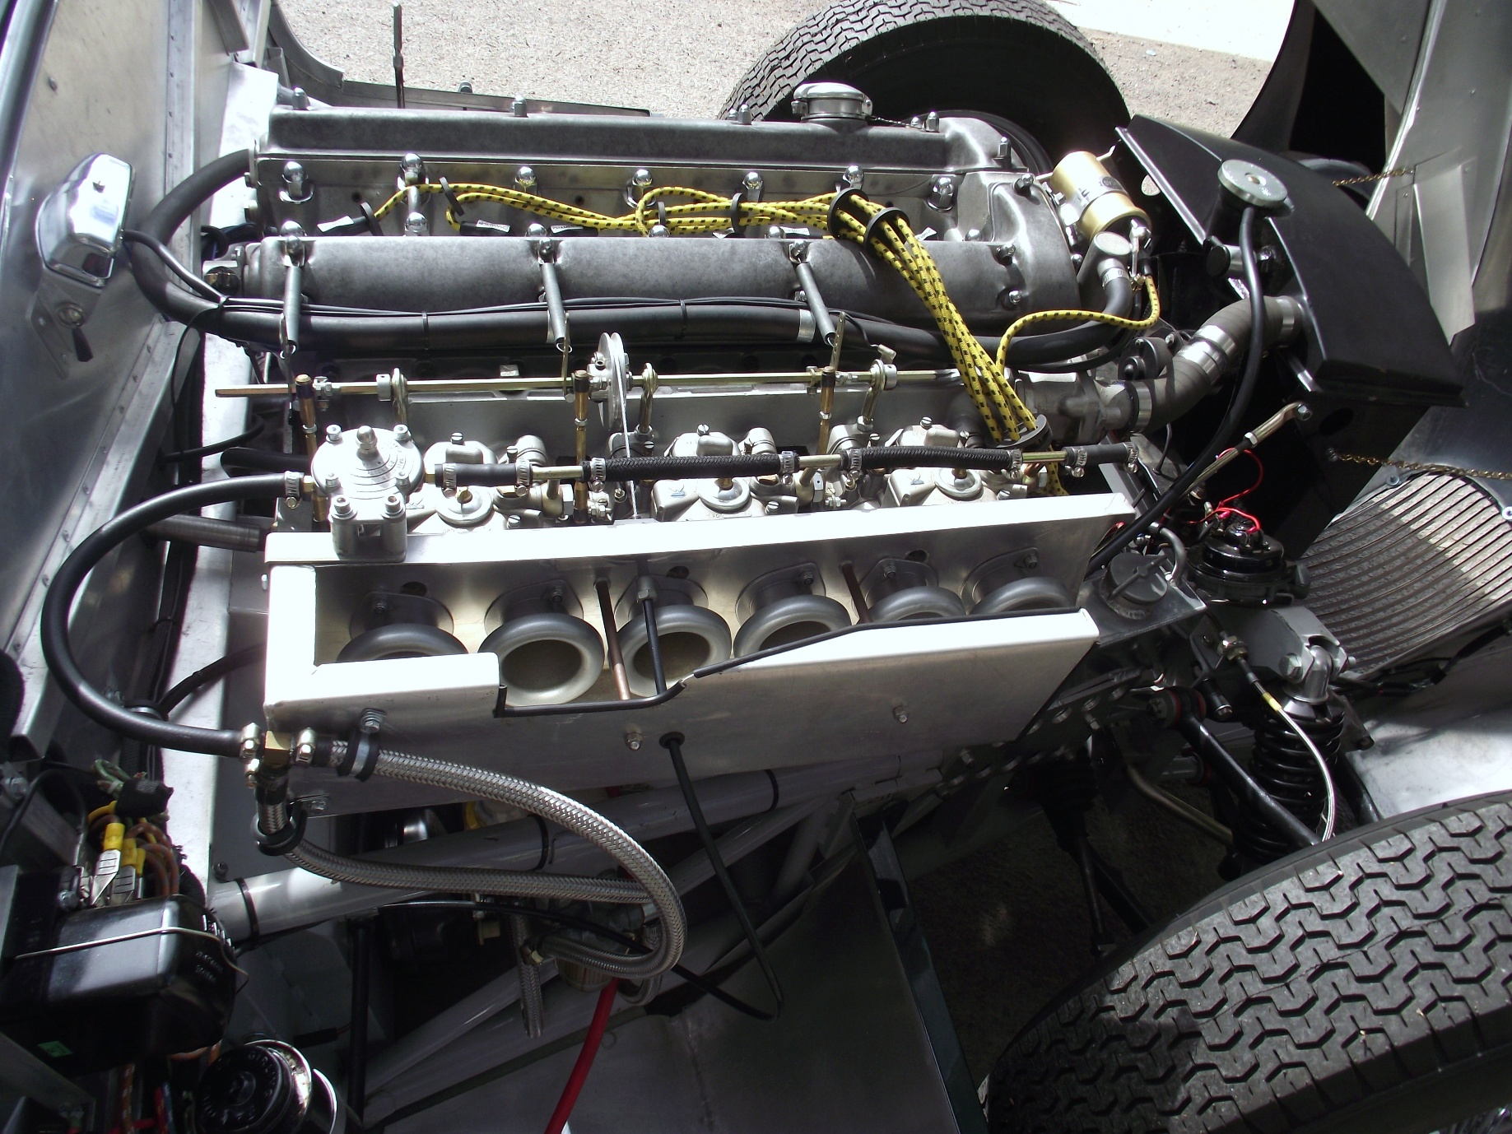
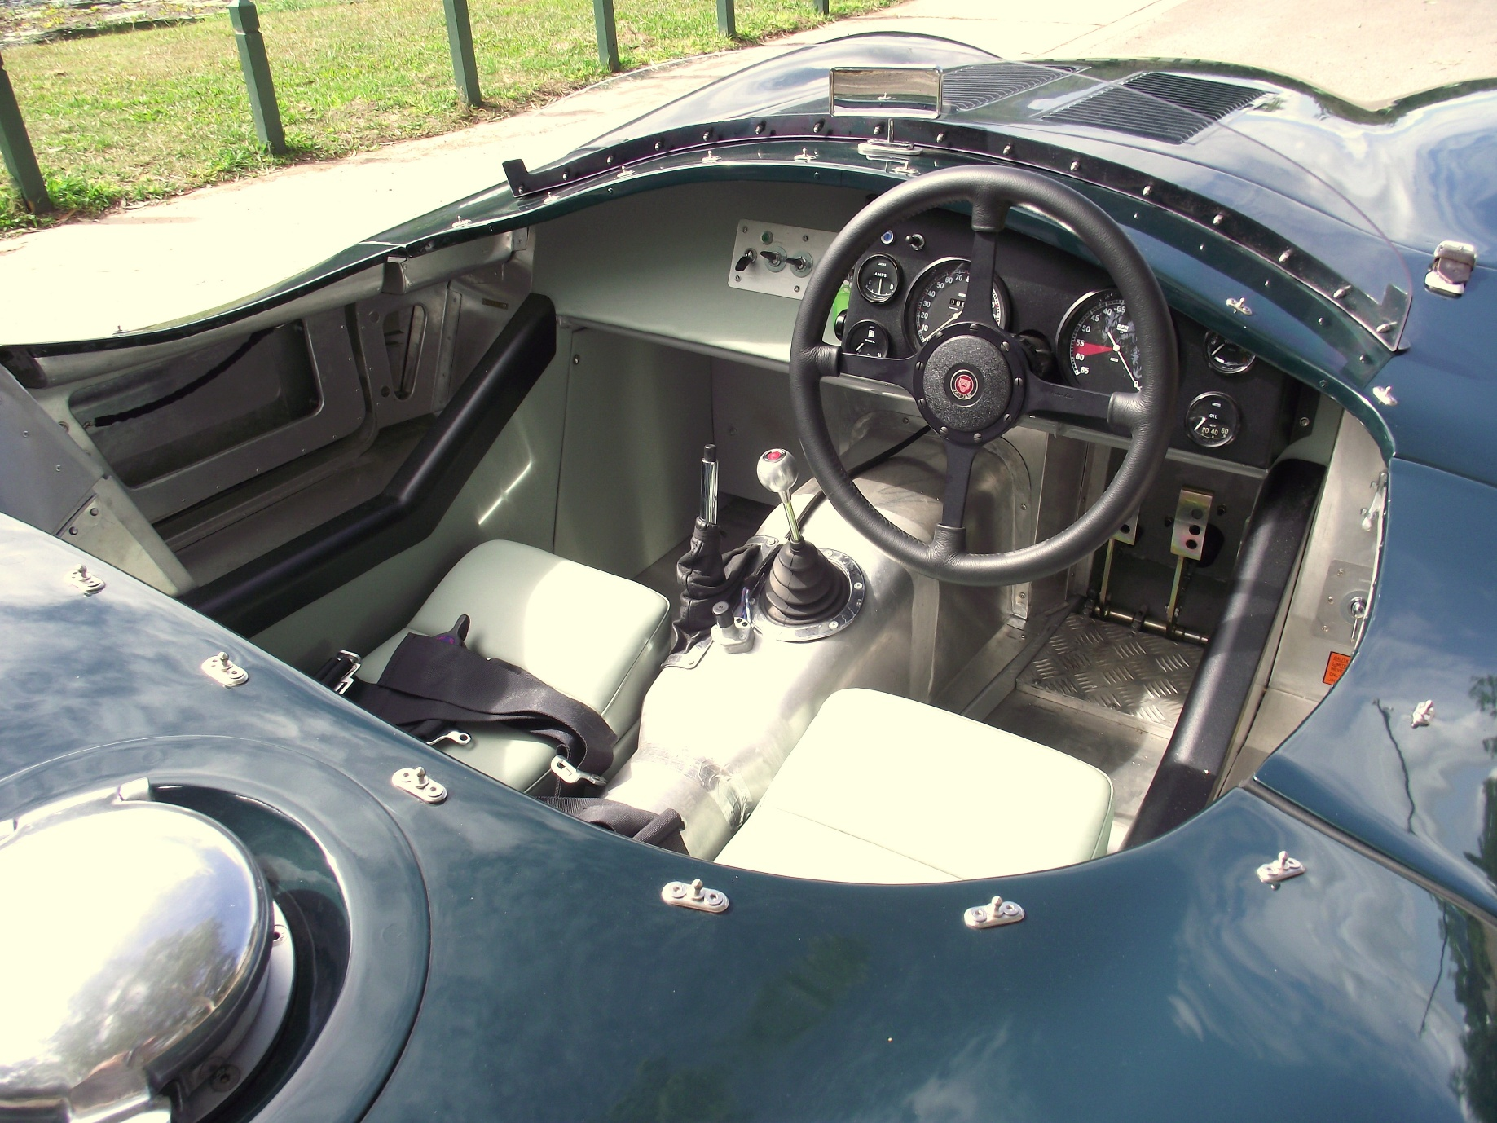
Dick did bring this Jaguar to two events in Townsville with our club once completed – the first was at an All-British Day at the Cathedral School and a Marque Club car show in City Markets. His Jaguar was sold a couple of years ago for about $200,000 and rumor has it that it was in a museum in Southeast Queensland. There are still only a couple of original Jaguar Type C race cars still in existence in the USA and UK with a reputed price tag of several million dollars.
When he first moved to Greenvale he had brought with him another car – a 1981 Mitsubishi Lancer 2 litre turbo AWD that needed some work as a rally car. The only rally event he ever raced at was in the 2018 Great Barrier Reef Targa based out of Cairns. By my calculations he would have been 85 years of age for that event. On checking with a couple of Greenvale residents they tell me he is still in remarkably good health at about 90+ and has been touring around Europe in a motorhome.
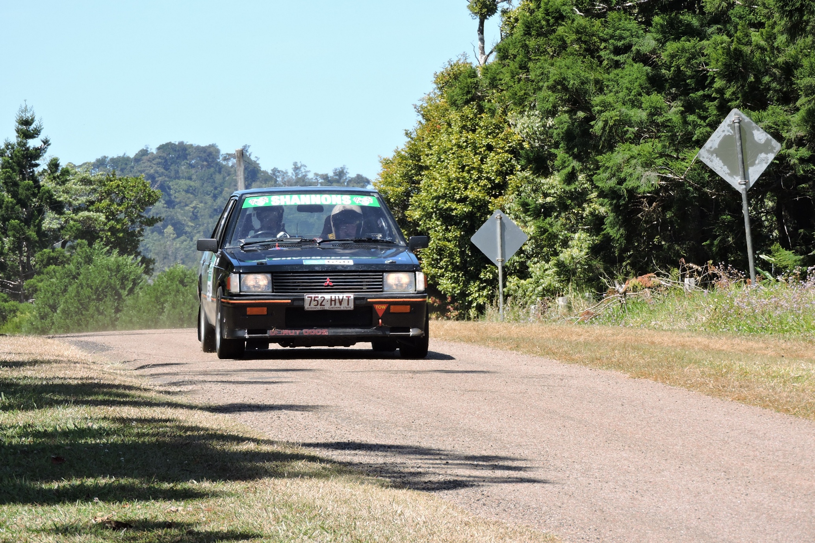

Upcoming Events – November 2025
- 5 November: Mid-Week Drive – 9:00 AM, WildCatz Indoor Sports Arena
- 8 November: Monthly Club Drive – Details TBA
- 11 November: Monthly Meeting – 7:30 PM, Rodders Club House
- 19 November: Mid-Week Drive – 9:00 AM, WildCatz Indoor Sports Arena
- 20 November: Club Dinner – 6:30pm Venue TBA
- 29 November: Xmas Party – 6:00pm Brothers Leagues Club

SUNDAY | MONDAY | TUESDAY | WEDNESDAY | THURSDAY | FRIDAY | SATURDAY
30 |  |  |  |  |  | 1
2 | 3 | 4 | 5  MID WEEK DRIVE | 6 | 7 | 8  CLUB DRIVE
9 | 10 | 11  CLUB MEETING | 12 | 13 | 14 | 15
16 | 17 | 18 | 19  MID WEEK DRIVE | 20  CLUB DINNER | 21 | 22
23 | 24 | 25 | 26 | 27 | 28 | 29  XMAS PARTY

FNQ Chapter
Weekly drives meet at 9:00 AM every Wednesday at the Tolga Pub. Recent destinations include the Gillies Roadhouse.

Weekly Sunday Drives
Meet every Sunday at 9:00 AM at Sk8way for a casual, destination-decided-on-the-day drive. All SIV drivers welcome!

Motorsport Highlights – November 2025
- The Phillip Island Auto Racing Club's (PIARC) annual Island Magic event returns to the Phillip Island Circuit on November 22 and 23, 2025.
- 27-30 November: Repco Supercar Championship Adelaide
- GASOLINE ALLEY RIDE NIGHT · Sat 1 Nov 2025

From the President
Cheapa Auto Spares Sprint Series – Round 8
Well, that is it. We are done for the year, and much fun has been had. I would like to thank Cheapa Auto Spares for their ongoing support of our event, with Phil already committing to our series for the next year.
Next, I must mention our hard-working volunteers. Without our magnificent crew, we would not have these events. They work tirelessly, with a lot of work being done prior to the event, during the event and of course after the event.
Finally, thanks to all our competitors. I must admit that I enjoy our events. I think it is great watching the improvements made by many of our competitors.
So, onto the event.
Class 2 The Hyundai Excel class plus the Swift. Jayke Clouton continued his untouchable run in the super swift Excel (ha ha). 2nd in class was relative new comer Stacey Lee with Cam Brown 3rd in the swift. Phil Wilcox and Liat Talora 4th and 5th, and a sneaking suspicion Dale Stevenson did not run a transponder.
Class 3 First timer Fred Van Der Hayden won the class with a great time of 1 minute 30, Alex Teazis and Ian Jorganson rounding out the podium places. Silvano was pipped into 4th, with Troy Tappenden and Simon Howser covering 5th and 6th and 7th in class, Nadine Jorgensen, with my vote for the drive of the day. Nadine’s 1st lap was a 2-minute run, but by end of the day had got down to 1 minute 39, awesome result.
Class 4 DATSUN 1600, what else can I say. Michael Cutuli’s new toy is really cool, and a 1 minute 19 lap time is just as cool as the car. Great result, great car and as soon as he moves the driver’s seat back, I will be fine to drive the beast. Lindsay Stone was fast enough for 2nd, with the unlucky Pat Barnett finishing 3rd with his 2 timed laps. 4th and 5th were the Hyundai Ns of Daniel Bott and Ross Reynolds with Peter Harben in the V6 Celica in 6th. 7th was another N being driven by Scott Olufson with Andrew Kearney and Michael Ellis in their Commodores covering 8th and 9th.
Class 5 Dominated by Benjamin Brooksby.
Class 6 Corbin Cutting with his first-class win (I think), John Sinclair took out second and Bradley Gilroy in 3rd.
OUTRIGHT: Michael Catuli, Datsun 1600. Once again, wow. 2nd was Lindsay Stone in the RX7 and Corbin Cutting an excellent 3rd outright.
As usual, it was a great day, great racing and great people. I am already looking forward to 2026, see you then, if not before.
Zeds Rule,
Michael
NAME | CLASS | BEST TIME
Michael Cutuli | CLASS 4 | 1:19.276
Lindsay Stone | CLASS 4 | 1:24.111
Corbin Cutting | CLASS 6 | 1:24.729
Benjamin Brooksby | CLASS 5 | 1:26.811
John Sinclair | CLASS 6 | 1:27.027
Pat Barnett | CLASS 4 | 1:28.964
Daniel Bott | CLASS 4 | 1:29.265
Daniel (Ross) Reynolds | CLASS 4 | 1:29.425
Fred Van Der Heyden | CLASS 3 | 1:30.292
Jayke Clouten | CLASS 2 | 1:30.922
Alex Teazis | CLASS 3 | 1:31.089
Peter Harben | CLASS 4 | 1:31.476
Scott Olufson | CLASS 4 | 1:32.005
Bradley Gilroy | CLASS 6 | 1:32.348
Ian Jorgensen | CLASS 3 | 1:32.477
Silvano Nobile | CLASS 3 | 1:32.539
Stacey Lee | CLASS 2 | 1:34.104
Cameron Brown | CLASS 2 | 1:34.207
Troy Tappenden | CLASS 3 | 1:34.543
Andrew Kearney | CLASS 4 | 1:35.112
Michael Ellis-Doidge | CLASS 4 | 1:35.784
Simon Howser | CLASS 3 | 1:36.541
Philip Wilcox | CLASS 2 | 1:37.373
Nadine Jorgensen | CLASS 3 | 1:39.507
Liat Talora | CLASS 2 | 1:41.314

My involvement with the club: Michele Fraser
Thought I would share a little insight into my involvement with the club. Jeff and I joined the club in 2003 as we had an MGTF and an MGB. Through those early years the club attended quite a few car displays, and we were always there with either one or both cars. We have since sold our MGTF (this year) and still have another MGB besides our original one (which is now in pieces as Jeff is going to put a V8 in it!) Our youngest had to sit through these as well so kudos to him for not complaining. In 2010 he turned 15 and decided to drive the club car in the sprints out at the go-kart track. Below is a couple of photos of his trophies. Having the club car and learning to race it was a great way for him to learn to drive and how to handle a car. “Cookie” was very helpful in this regard. Something must have rubbed off because when he turned 18, he imported a Toyota Sprinter (86) from Japan and has it stored in our shed – a car he loves. I too have a Toyota 86 (Blackline Limited Edition) and love driving it. Not sure if I want to race it though as I couldn’t bear to see it damaged if I had a crash! Jeff and I have always been involved in the social side of the club and several years ago I took on the role of social secretary and media officer. I have really enjoyed organising outings and dinners for the club. It’s a good way to meet new people and make lifelong friends. Jeff, Phil & Ray have been organising the mid-week drives for a few years now and enjoy their outings. In 2023 or thereabouts I took on the role of club treasurer also and in 2025 have added Secretary to my portfolio! Recently, I have been helping at the track and have now managed to obtain my official’s licence so the racing fraternity will be seeing a bit more of me from now on. I look forward to many more years helping the club and meeting new people.
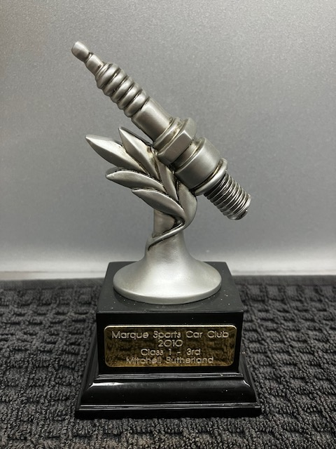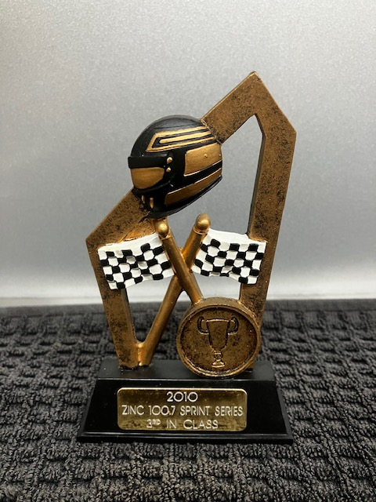
🏁 Jokes of the Month
What do you call a vicar on a motorcycle?
Answer. Rev! Rev! 😄
What's the cheapest thing on a BMW Motorcycle?
Answer: The rider 😄
If you drive a Subaru in reverse, what are you?
Answer: U r a bus 😄 😄 😄
🧠 Fun Fact
The first car race was contested in Greater Manchester.
The first purpose-built motor racing circuit was in Australia.
The first Grand Prix motor race predated Formula One by 40 years.
Ray Harroun won the inaugural Indy 500 in 1911.

📣 Got a Story to Share?
We're keen to feature your stories in upcoming newsletters! Whether it’s about your car, a rebuild journey, a favourite road trip, or even a spotlight on a fellow member—send it through. We'd love a few photos too.
We’re also starting a Member Spotlight section to introduce the people behind the cars. Share a short bio, how you got involved with the club, or a memorable motoring moment.
Send your contributions to Michele at: social@marquenq.com.au
(Don’t be shy—we’re still waiting… crickets chirping) 🦗😉

OUR PLATINUM SPONSOR IS:



REMEMBER TO SUPPORT THOSE THAT SUPPORT US.
LET THEM KNOW YOU ARE WITH THE MSCRNQ TO
RECEIVE A DISCOUNT!

