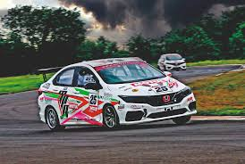

Monthly Newsletter



December 2025 Newsletter

Event Recaps
- Mid Week Drive – 5 November
Drive around town followed by morning tea at Bright Eyes Café. Wonderful morning had by all.
- November Club Drive – 8 November
We all met up at Weir State School and went for a bit of a tour around town. This was followed by fish and chips from Tobin’s seafood which was eaten at Soroptimist Park, Belgian Gardens. A lovely evening of chat interrupted by the odd midge!
- Club Meeting - 11 November
See minutes on website. Lively discussion regarding new road into DriveIt track, car show(s) and suggestions from racers regarding pit area, compressor and megaphone. It was also announced that Cheapa Auto Spares will have the naming rights to our 2026 sprint series. AGM in December due to complying with our constitution. Also changes to be made to the constitution.

- Mid Week Drive – 19 November
Once again a tour around town followed by lots of chat at the Wounded Heroes Café on Woolcock Street.
- November Dinner - 20 November
We have dinner at Tori & Co – Korean Restaurant. As usual the food was superb, and everyone had a thoroughly good time.
- Christmas Party - 29 November
Well, what can I say. We had a great evening of fun and games at Brothers. The food was tasty with a good variety. We had a few lucky door prizes which were won by various people. Michael Ellis-Doidge had won the lucky door prize with the elf under the chair, but the elf was playing hide and seek with him! Best costume went to Silvano (photo’s below) and the members draw $100.00 won by Mike Summers. The cake raffle was won by the Packhams and the second cake was won by Denise Skimmings. Ray Scagliotti was presented with a trophy for club enthusiast of the year having attended/participated in the most events throughout the year.

Thanks, this year must also go to the various members that have participated in any event because without you we wouldn’t be a club. Also a BIG thank you to those that have helped run the sprints this year – Alan Nelson, Errol Reeves, Leslie Reeves, Michael Seymour, Noel Radford, Cam Brown and Troy Tappenden. Thanks to the fire marshals and ambulance staff. Big shout out to Evonne and Jo for their catering. Also, thanks again to Evonne and Jo for decorating the Christmas Party and for purchasing various prizes for the evening. I hope I haven’t missed anyone – kick me if I have. Enjoy the photos!

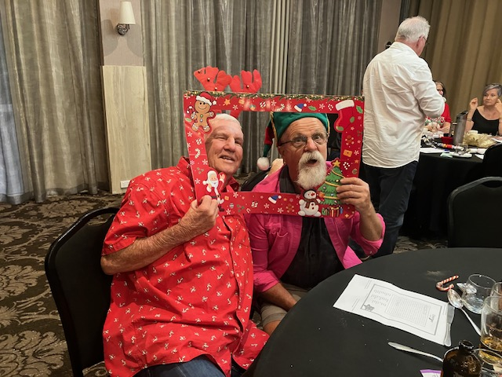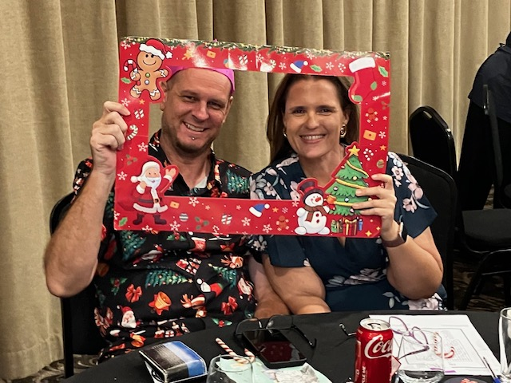

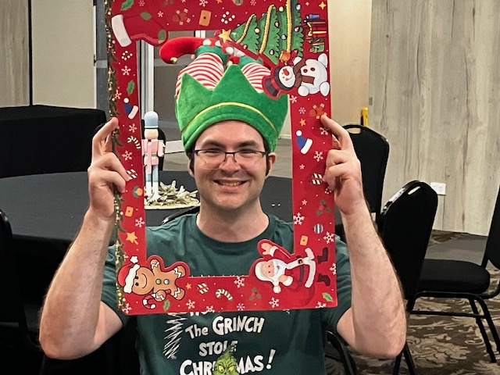

Club Announcement
- Digital Membership Cards Are Here!
With memberships due in February just a reminder that as of 2026 members will receive a .png card via email, scannable with store card apps or Google Wallet. Unfortunately, Apple Wallet is not supported currently. You can also print your card or save it to your phone’s gallery.
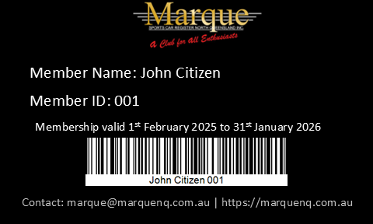

Stop Press
- AGM
Our AGM will be in December this year as we are trying to align it within the rules of our constitution. Nomination forms and notices are available on our website.

Upcoming Events – December 2025
- 3 December: Mid-Week Drive – 9:00 AM, WildCatz Indoor Sports Arena
- 9 December: AGM – 7:30 PM, Rodders Club House
- 13 December: Monthly Club Dinner – Fairfield formerly Oonoonba Hotel
- 17 December: Mid-Week Drive – 9:00 AM, WildCatz Indoor Sports Arena
- 20 December: Monthly Drive – Details TBA
- 31 December: Mid Week Drive - 9:00 AM, WildCatz Indoor Sports Arena

SUNDAY | MONDAY | TUESDAY | WEDNESDAY | THURSDAY | FRIDAY | SATURDAY
 | 1 | 2 | 3  MID WEEK DRIVE | 4 | 5 | 6
7 | 8 | 9  AGM | 10 | 11 | 12 | 13  CLUB DINNER
14 | 15 | 16 | 17  MID WEEK DRIVE | 18 | 19 | 20  CLUB DRIVE
21 | 22 | 23 | 24 | 25 | 26 | 27
28 | 29 | 30 | 31  MID WEEK DRIVE

FNQ Chapter
Weekly drives meet at 9:00 AM every Wednesday at the Tolga Pub. Recent destinations include the Gillies Roadhouse.

Weekly Sunday Drives
Meet every Sunday at 9:00 AM at Sk8way for a casual, destination-decided-on-the-day drive. All SIV drivers welcome!

Club Car of the Month
KENT SUTTON’S 1960 DAIMLER SP250 “B” Spec
Story and photos by Skimmo
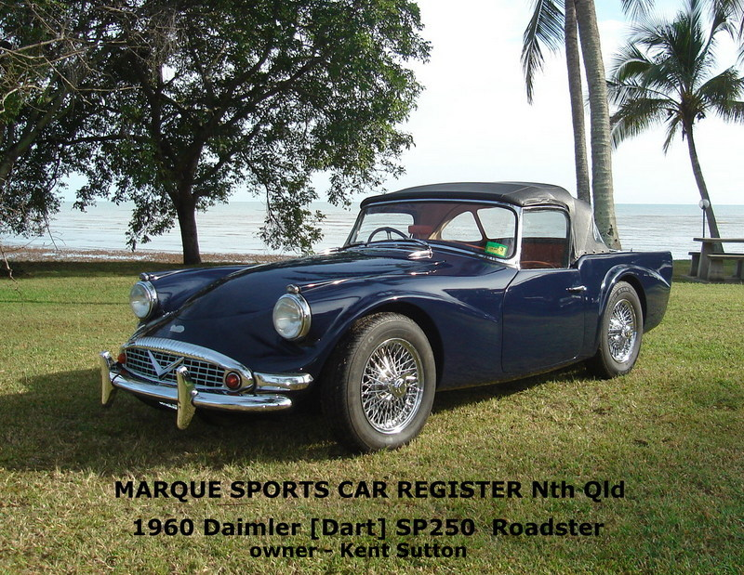
These rare sports cars were sold in limited numbers in Australia. Unusual in design for the period as a very attractive sports open top coupe with a 2.5 litre V8 engine.
Kent’s car was built in the UK in December 1960, later shipped to Australia and sold to the first owner in Geelong [Victoria] by1961. Just 2 owners later and having accumulated 42k. miles it was purchased then by Kent in 1973. He used it as his “daily driver” for 3 years whilst living in Tasmania and the mileage had got up to 82k. He did feel it needed some attention and had put it off the road into storage in 1976. He later moved home to Townsville and finally had it transported to Townsville in 1980.
A total restoration was begun here in 1982 when it was totally disassembled with the fiberglass body removed. This very long restoration all happened under a high-set old Queenslander house in Carr Street Hermit Park. The chassis was found to be in good condition, was cleaned and repainted in a Zinc based industrial paint. The engine was also replaced at some stage with a same style 2.5 litre V8 in good order from a Daimler saloon which he had overhauled with new rings and bearings along with the head rebuilt reseating the valves and fixing some small corrosion issues to be fitted to the Daimler Sports Car.
The original 2 carburetors [1 3/4 SU] were replaced with the much larger 2-inch SUs. The inlet manifold was then heavily modified to improve the flow rate and fit the larger carbs. These mods along with a new ignition system must have helped to vastly improve the performance.
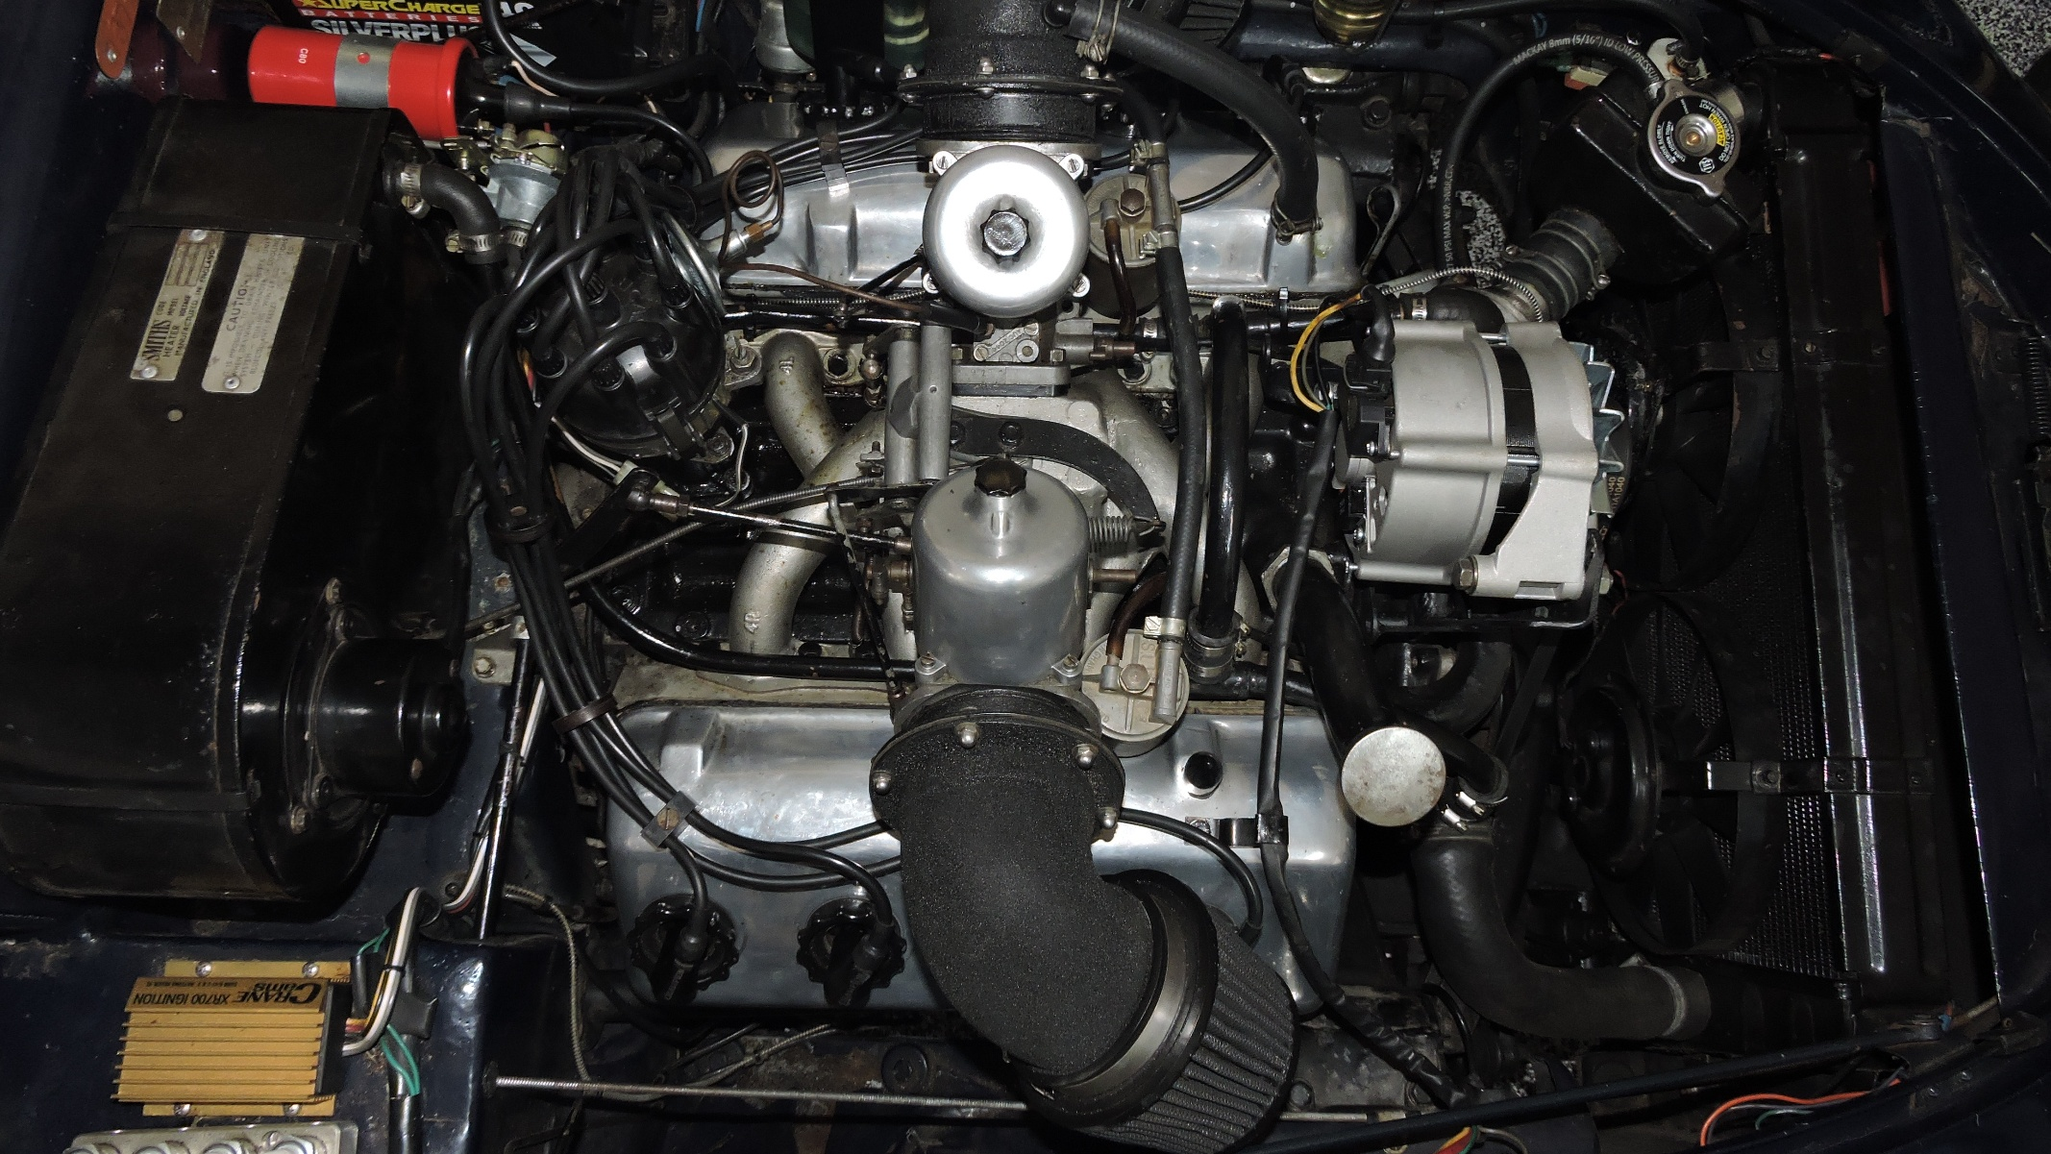
Lots of other work was done with the gearbox being overhauled and fitted with an overdrive that works on the 2nd,3rd and 4th gears. The differential ratio was also changed to match the new gear ratios a little better.
The body of the car being fiberglass had no rust. However, it was given some extra layers of fibreglass in numerous areas underneath to strengthen the bodywork and other areas to improve the exterior finish. When the body was eventually refitted the final paintwork was done in the “Oxford Blue” - a Rolls Royce colour differing from the original Off White paint.
The other thing of importance to mention in the outside appearance is the fantastic 72 wire spoke chrome wheels fitted before being registered. Wow Kent – would be an ongoing long task to have them still looking new.
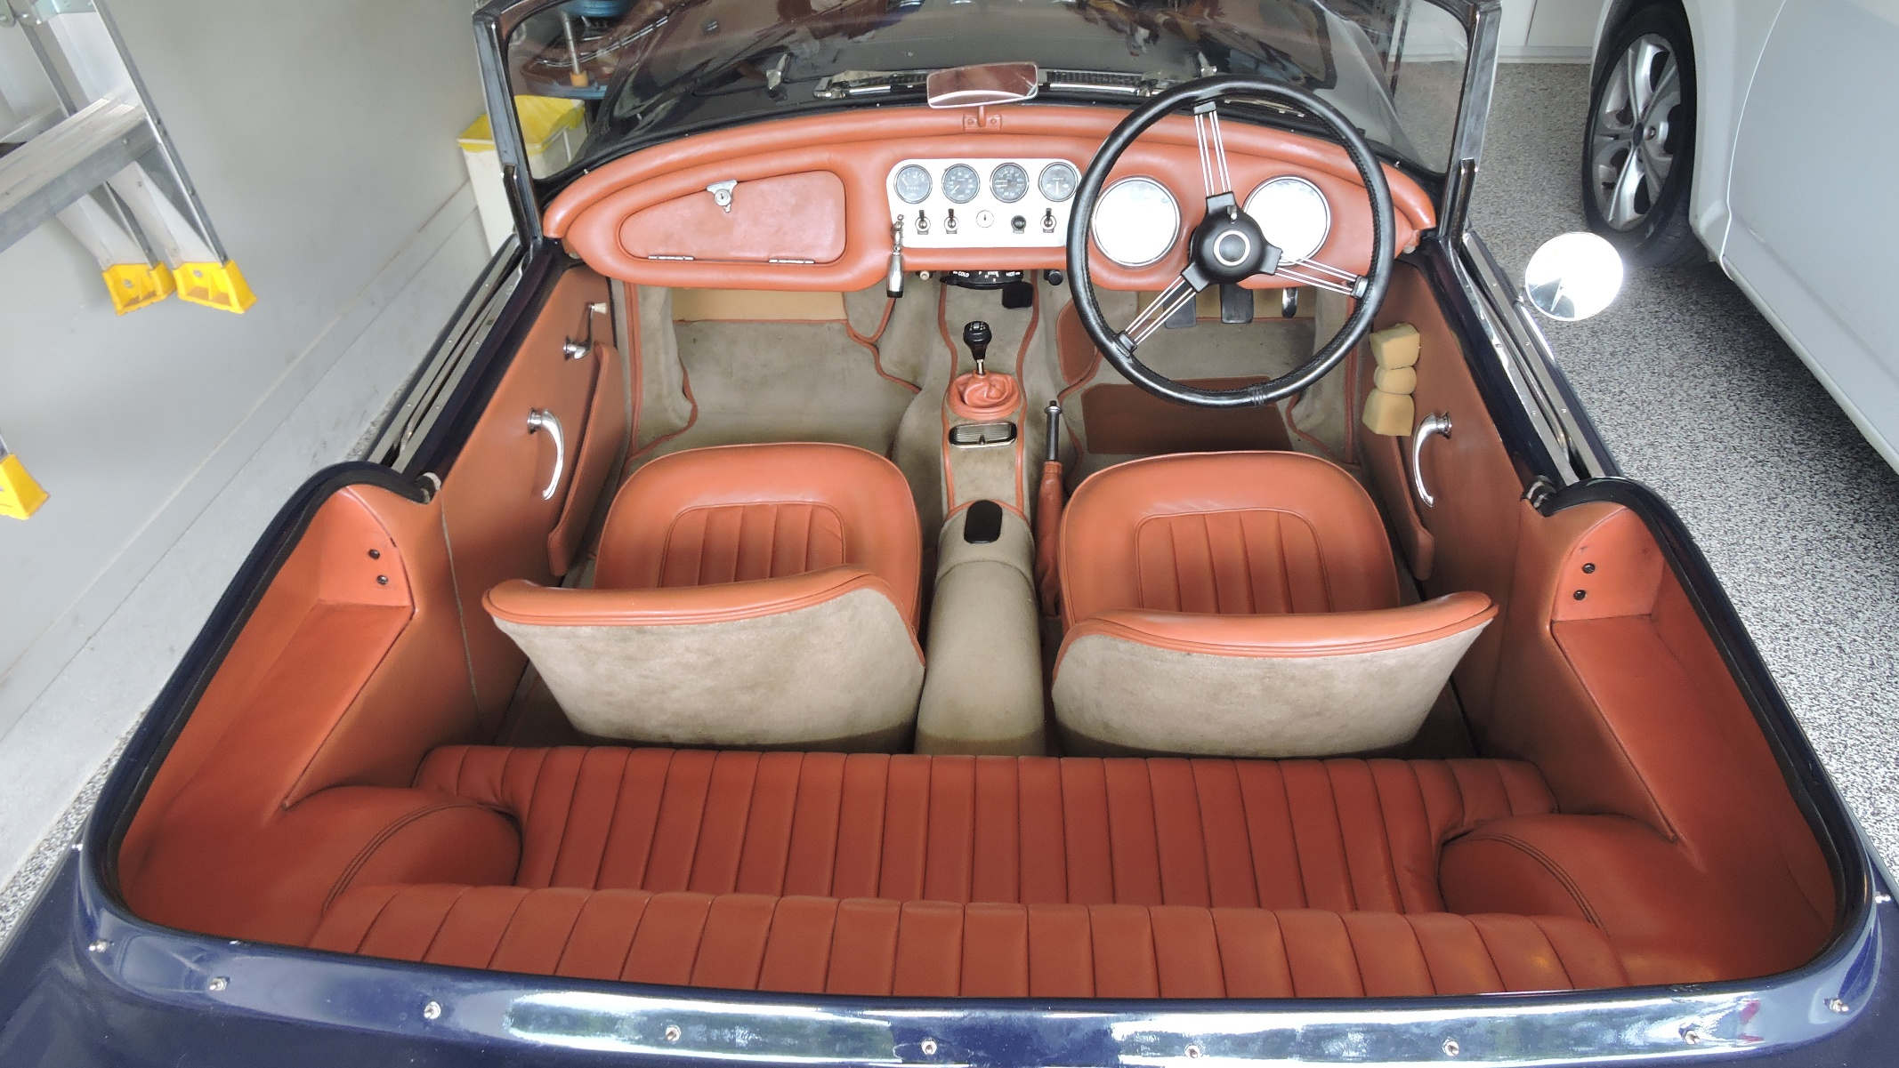
The interior finish is certainly first class. The original leather trim colour - “light tan” – that Kent wanted was very difficult to find. He finally did find a leather supplier in Brisbane who could especially tan a skin to that exact colour. The job to re-upholster the interior fell to the highly regarded Paul Marsh here in Townsville and I believe it was in his care for about 6 months. His directions were to follow originality in all the seats and carpeting - right down to the instructions on the number of pleats to be exactly as they would have been, was followed. The dash and door trimming is also superb. The photo attached of the interior is not accurate in its colours – just a photo lighting problem. In real life they are all the same colour leather. In my many years as a classic car enthusiast – this is best retrim I have ever seen.
The restoration place in Carr Street was just around the corner from my shop way back then, Top Gear Auto Parts, and was where I became involved in a small way. All the bushes were replaced with soft polyurethane bushes. They were difficult to find and only sourced by trying to find something like the required sizes – incredibly they turned out to be mostly Triumph parts. I had also talked him into replacing the original Lucas ignition points with a then new high voltage Crane optical ignition device which is still working beautifully and is more reliable than the original Lucas points. Along with a new electric fuel pump and higher capacity radiator system – all of this came together during the very long restoration period – a total of 25 years to be finally registered on the road in 2009. It was put on display at that year’s All British Day to garner the top award of the show as “BEST CAR”.
There must another award for this task – 25 years of dedication to this long restoration task on this car to achieve having it look so good and another 16 years of care since. It is now 65 years old I would still label it as a “Stunning Car Show Standard” car despite it still being driven regularly.
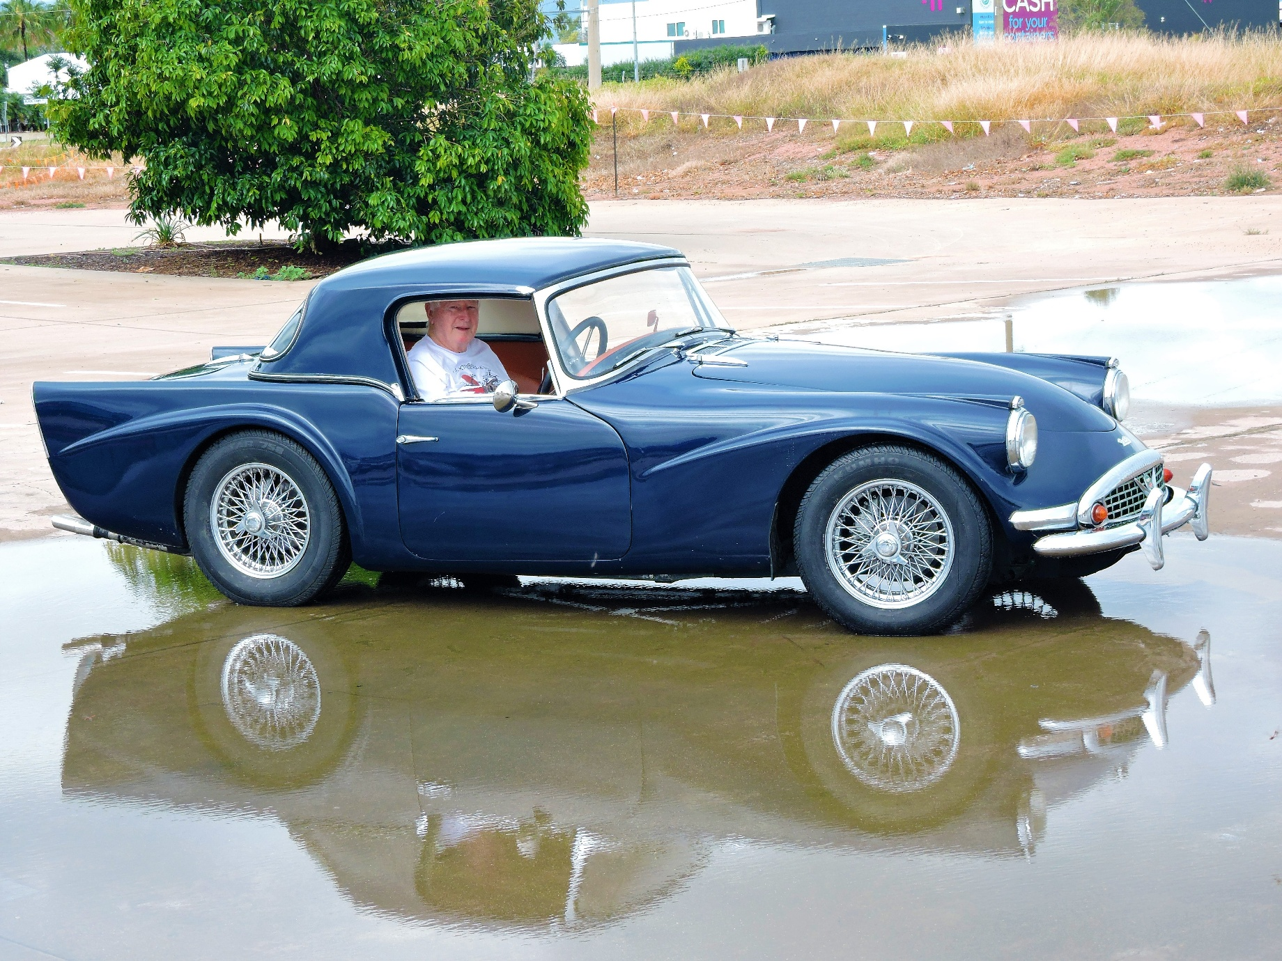
🏁 Jokes of the Month
What do race car drivers wear under their fire retardant suits?
Speedo’s! 😄
"My little cousin was showing off that he sleeps in a race car bed. Jokes on him I sleep in a real car." 😄
Why did the car get disqualified from the neighborhood drag race?
No spoilers! 😄

🧠 Fun Fact
The first motorcycle needed "training wheels": The very first motorcycle, the "Reitrad" or "running machine" invented in 1817 by Baron Karl von Drais, had no engine and required balance and steering with the rider's feet. It was effectively a "running machine" with training wheels, which is why some people joke the first motorcycle needed training wheels to be ridden.
The first "Indian" motorcycle was built in 1901 in Springfield, Massachusetts, and was considered the first successful motorcycle.
Helmets have been proven to save lives, and their importance was recognized after Hugh Cairns' studies in the 1930s on motorcycle crash injuries.
📣 Got a Story to Share?
We're keen to feature your stories in upcoming newsletters! Whether it’s about your car, a rebuild journey, a favourite road trip, or even a spotlight on a fellow member—send it through. We'd love a few photos too.
We’re also starting a Member Spotlight section to introduce the people behind the cars. Share a short bio, how you got involved with the club, or a memorable motoring moment.
Send your contributions to Michele at: social@marquenq.com.au
(Don’t be shy—we’re still waiting… crickets chirping) 🦗😉

OUR PLATINUM SPONSOR IS:



REMEMBER TO SUPPORT THOSE THAT SUPPORT US.
LET THEM KNOW YOU ARE WITH THE MSCRNQ TO
RECEIVE A DISCOUNT!

