

MARQUE MONTHLY NEWSLETTER

January 2026 Edition
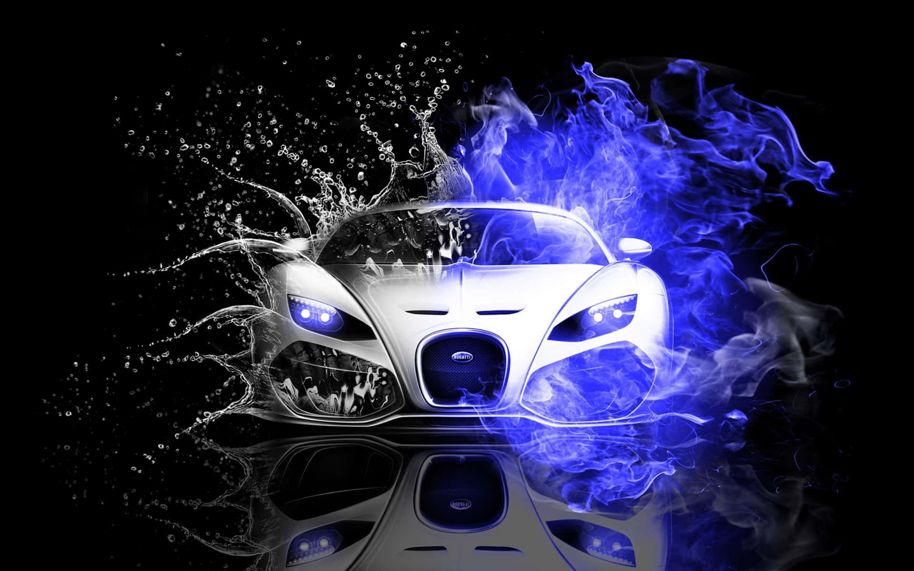

🚗 Event Recaps
Mid-Week Drive – 3 Dec
Cruised around town, then relaxed at ??. Great vibes all around.
AGM – 9 Dec
Held at Rodders Clubhouse. Minutes available on the club website: www.marquenq.com.au/paperwork
Committee elected same as previous years. This year we have an extended race committee made up of the following members: Geoff Parnell, Noel Radford, Troy Tappenden, Shane Corradi, Lloyd Struber, Errol Reeves, Michael Seymour, Alan Nelson, Cam Brown, Michele Fraser, Michael Ellis-Doidge. A club display/show committee was also formed – committee members are: Chris Mills, Ray Scagliotti and Warren Skimmings. They are hoping to hold 3 major events in 2026. Another newsworthy point is that the updated constitution was voted in and will be submitted to the office of fair trading in due course.
Club Dinner – 12 Dec
Fantastic meal at the Fairfield Hotel (formerly the Oonoonba Hotel). Oh, what a night! We had 25 turn up for our December dinner. This was great to see. One would have thought this close to Christmas that nobody would be interested in another night out but how wrong can you be. It was good to see some new faces and of course all the old faces. We raffled off a Bunnings voucher, and the winner was Alan Stibbs with lucky number 33. Congratulations Alan.
Mid-Week Drive – 17 Dec
Another scenic drive, ending with lively chats at Café 63 Upper Ross. Quite a few attendees and a great morning tea had by all.
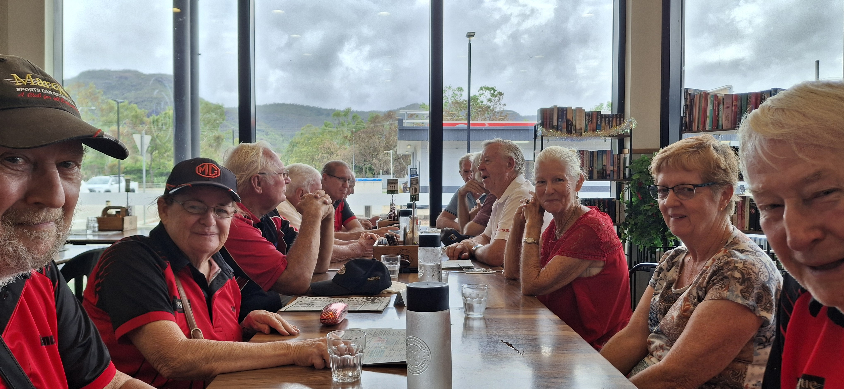

Monthly Drive – 21 Dec
Early start to the day! 7:30am drive around town culminating at the Fifth Avenue Boat Ramp Recreational Park. BYO breakfast saw a few turn up but not that many. We had a good old chin wag, delightful breakfast and great company. After the early start it was off home to have a nap!
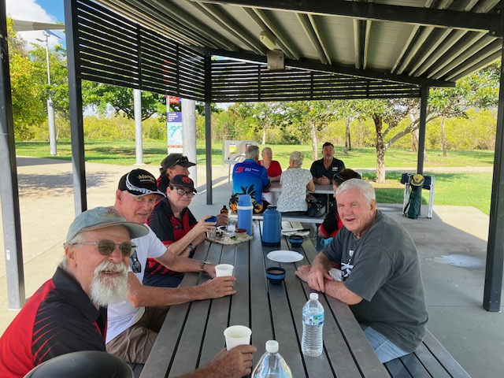
Mid-Week Drive – 31 Dec
Great drive around town with a bit of rain followed by morning tea at Caltex Servo Cluden. Only 4 attendees due to the weather no doubt but I believe a good chat was had by all. A couple of racers attended so that was great to see.

📢 Club Announcements

Membership Due by 1.2.26!
Membership fees are due by 01.02.2026. $40.00 per year for a family – over 18-year-olds require their own membership. This year everyone will receive a digital card that can be saved to your mobile phone as a photo, in your card file (Klarna) or in your Samsung wallet. Unfortunately, it’s not able to be saved into an Apple Wallet. You will need to send in a completed membership form (https://marquenq.com.au/membership) or complete our online membership form: Membership Form for the Marque Sports Car Register Nth Qld Inc. – Fill out form along with your payment.

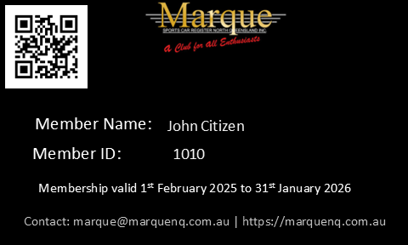

🗓️ January 2026 Events
- 13 Jan: Club Dinner/Meeting – My Favourite Thai
- 14 Jan: Mid-Week Drive, 9:00 AM @ WildCatz Indoor Sports Arena
- 18 Jan: Monthly Drive - TBA
- 28 Jan: Mid-Week Drive, 9:00 AM @ WildCatz Indoor Sports Arena

FNQ Chapter: Weekly drives every Wednesday, 9:00 AM @ Tolga Pub.
Sunday Drives: Meet 9:00 AM @ Sk8way—destination decided on the day. All SIV drivers welcome!

🚘 Club Car of the Month
Nothing this month as Warren is having a break but we look forward to his next article.

😂 Jokes of the Month
- Q: Why was the car always tired?
- A: It never took any brakes.

- Q: What’s a movie they could never make about a Lamborghini?
- A: Silence of the Lambos.

- Q: Why did the man remove the wheels from his car before a road trip?
- A: He wanted it to drive tirelessly.

🏍️ Fun Fact
The Orbital: A Revolutionary Aussie Engine
Here's a fascinating little car trivia titbit: The Orbital Engine, a revolutionary invention by Australian engineer Ralph Sarich in the 1970s, transformed the automotive industry. This type of internal combustion engine adopted a unique approach to air and fuel mixture, using a high-pressure air-fuel mist that enhanced combustion efficiency. The Orbital Engine brought substantial improvements to fuel economy and reduced harmful emissions. This invention enabled cars to run more miles per gallon, making them more economical to operate. Additionally, the engine's reduced emission levels contributed to a decrease in air pollution, aiding environmental conservation efforts. Sarich's Orbital Engine remains a testament to the potential of innovative engineering in addressing global challenges.

🌟 Member Spotlight
We want to feature your stories! Share your car journey, favorite road trip, or a member bio. Send your stories and photos to Michele at social@marquenq.com.au. Don’t be shy—let’s get to know each other!

🏆 Sponsor Shoutout
OUR PLATINUM SPONSOR IS:



REMEMBER TO SUPPORT THOSE THAT SUPPORT US.
LET THEM KNOW YOU ARE WITH THE MSCRNQ TO
RECEIVE A DISCOUNT!

