

MARQUE MONTHLY NEWSLETTER

April 2026 Edition
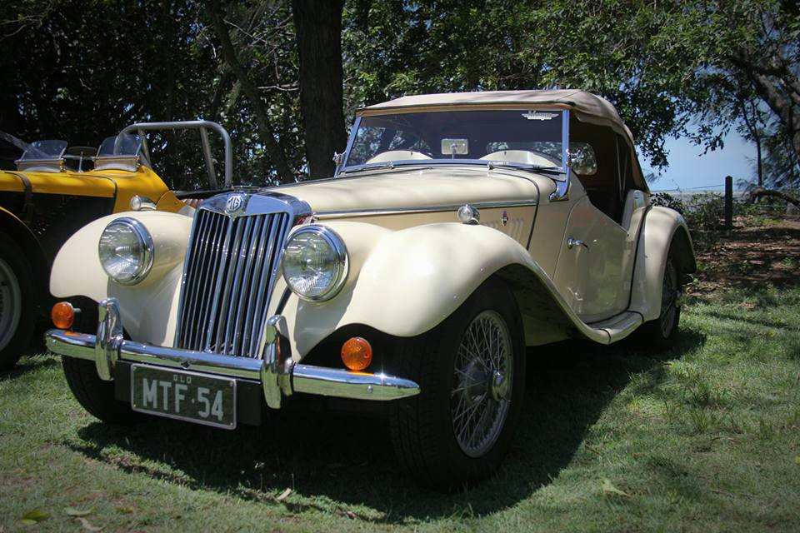

🚗 Event Recaps
Club Dinner/Meeting – 10 March
This month we went to Brothers. What can I say – it was extremely noisy! Probably the time we went was very conducive to children so maybe our fault in that regard. Michael had a nice discussion with management! (Not)…… The food was great and we had a healthy discussion regarding our upcoming show at Cotters Market. Jo and Evonne are running an Easter ?raffle? more of a guess the number of eggs in a jar with the jar of eggs being the prize. Will discuss that further in the newsletter.
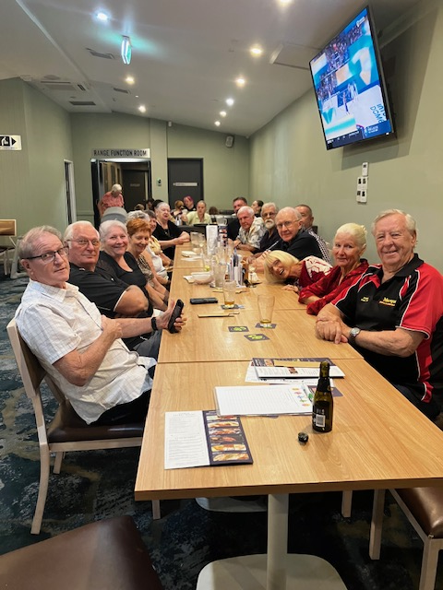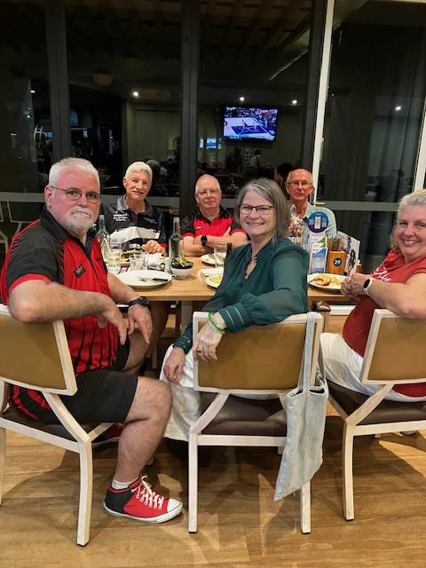
Mid-Week Drive – 11 March
After a lovely drive around town we headed to the Railway Café for morning tea. The day started off a bit wet but the sun eventually shone (for something different).
March Club Drive – 22 March
Dismal turnout really with only 8 of us off for breakfast at Happy Place Café. What can I say – delicious food, excellent service and very efficient. The place was packed and we only waited 15 minutes from being served to getting our food. For those of you that didn’t come – you missed a really great morning. Michael led the drive to breakfast and took us through the ‘burbs down to the Strand.
Mid-Week Drive – 25 March
The usual crowd turned up for Wednesday’s drive which was up to the dam to have a look at all the water. We then headed out to Brothers League’s Club for morning tea and another chat. Great morning had by all.

📢 Club Announcements

A huge thank you to Cheapa Auto Spares for their generous support of our club! 🙌

Thanks to their sponsorship, we were able to purchase transponders for our Sprint Series, helping us improve timing and enhance our race events for all competitors.

We really appreciate Cheapa Auto Spares supporting grassroots motorsport and our club community. Please support the businesses that support our sport! 🏁🚗

Membership Due 1.2.26!
Membership fees were due by 01.02.2026. $40.00 per year for a family – over 18-year-olds require their own membership. This year everyone will receive a digital card that can be saved to your mobile phone as a photo, in your card file (Klarna) or in your Samsung wallet. Unfortunately, it’s not able to be saved into an Apple Wallet. You will need to send in a completed membership form (https://marquenq.com.au/membership) or complete our online membership form: Membership Form for the Marque Sports Car Register Nth Qld Inc. – Fill out form along with your payment.


This is important as we need your CURRENT information for our database and to email membership cards.
Direct Deposit details are below.
Direct deposit membership fee into Bank of Qld account:
Marque Sports Car Register North Queensland Inc
BSB 124055 Account No. 20369426
Bank Reference: NAME
Past and present, new and old members welcome.
As per our website:
The MSCR is an active car club, that covers all car enthusiasts from racers, show and shiners, and even those who just enjoy driving their special car. To put your car on Club Registration, you must be an ACTIVE member of an affiliated car club.
For SIV registrations the club has been notified of the following:
Q.H.M.C. have been advised that Qld Police Service is checking Special Interest Vehicle drivers, for membership card or receipts of a membership club. Advise to carry event ratification with you when on a club event. Please be aware that you can be stopped, and you must be able to prove current membership of a car club that issues Dating Certificates, or risk losing your right to SIV registration.
For Racing members: as per AASA rules and your sub-reg docs:
Competitors must produce a valid and current AASA Competition Licence and a Club Membership Card.
The above will be enforced in 2026 and we will need to sight a current membership card.
**********************************************************************************************

🗓️ April 2026 Events
- 4 & 5 April: Round 2 Cheapa Auto Spares Sprint Event – Manton Park
- 8 April: Mid-Week Drive - 9:00 AM @ WildCatz Indoor Sports Arena
- 14 April: Club Meeting
- 18 April: Monthly Drive
- 23 April: Club Dinner
FNQ Chapter: Weekly drives every Wednesday, 9:00 AM @ Tolga Pub.
Sunday Drives: Meet at 9:00 AM @ Sk8way—destination decided on the day. All SIV drivers welcome!

Car of the month
MY FIRST CAR – Austin A30
STORY BY SKIMMO
My father brought his first new car in 1952 in Toowoomba. It was an Austin A30 “made in England” from the local dealer. We loved it painted in a light cream body colour with bright red trim. It certainly did look great for the era.
We then moved to Canberra in 1959 with the A30 to live where I completed my education. In 1962 Dad traded the A30 in on new Fiat 1100 and the A30 was offered to me to buy for 100 pounds. The deal was done and I soon had my Driver’s License in it at 17 years old.
I joined a local motorsport club intending to do some events in the A30 being a smart-arse intent on being competitive in it with little respect of how fragile it was in my hands. The original 848cc. engine was the first thing with a problem [loud knocking noise that wasn’t there earlier], most likely from being revved way too hard. It was soon replaced with a second hand 998cc engine. I had been doing motorkhana’s, a few rallies and other skids at a local dirt track. My father was not pleased with the abuse I was giving it and that brought on a shift to a friend’s spare garage nearby with plenty of tools.
We then embarked on a list of things we could do to make it more competitive. We wanted to make it lighter so most of the original trim was discarded. The bodywork was then attacked by drilling lots of large holes wherever we could with a 3inch drill thing we found at a building site. These were covered with flyscreen mesh and painted with a very light coat of something black like we would now call epoxy resin. Our attempt to make the bonnet, boot lid, and door skins using the same stuff was ugly so the outside bodywork got a coat of dark green paint brushed on. The main last job done was to install a Peugeot203 [1300cc] engine and gearbox. Our lightening project had worked as we had saved almost 180lbs off the original weight – then lighter than a current Mini850. Obviously, it could never be registered in this state in Canberra, so it only ever ventured out of the garage for a couple of drives and a blast at the local dirt track. So, this car’s residence in that garage was to be a long one – from 1963 to 1967.
In 1965 I moved [hitchhiked] to Townsville with very few possessions on my own for reasons too long a story to tell. I got a job eventually at Hollis Hopkins after knocking on lots of doors, wore out two pair of shoes trying, being told everywhere I was “overqualified” because of my partial university education.
Two years later while still in Townsville with the approaching Christmas in 1967 - I drove to Canberra in my “new” car for a holiday to see my dad and catch up with any friends still about down there. Photo of this car below [a highly modified early Holden] – I had brought from Keith Goodall Used Cars was my drive car to go to Canberra and back.
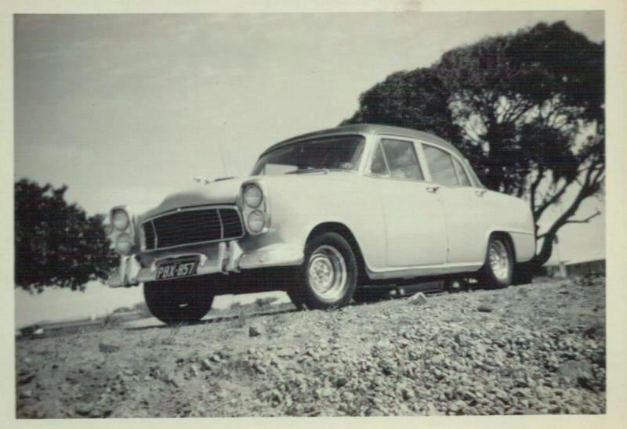
Whilst there I called on my friend who had my A30 still in his garage. Got it started easily and drove it around the block. He then told me of a race meeting coming up near Albury on Boxing Day. A few phone calls to people I still knew in the loop about what were my chances of getting a start. I still had my race license, so I drove my A30 (unregistered but still had the plates) down to the Hume Weir Race Track.
My entry was accepted to race as a “P Plater” in my highly modified but very scruffy A30. In the pits I was parked next to a young bloke who was also racing an Austin A30 and also on a “P Plate”. We chatted on lots subjects about our scruffy A30s, his holden engined A30, his and my “Nasho” Military “call-up”, the fact that it was at his first ever race meeting after entering month earlier at Winton that was a disaster mechanically and he didn’t get to race, Hume Weir was to be was my second go at the bitumen as well, and the fact that our birth dates were only weeks apart. We were both entered on the same class “Sports Racing Closed” which eventually became known as Sports Sedans today. All our races were on a handicap basis, fastest start last which worked out that I started near the first lot off and his A30 near last to start. In our three races I got caught up with and passed by the other A30. His car was very unpredictable and he had several spins – two I saw just as he went past me. I asked him about his spins, and he said his car was very unstable and no time had been spent on set-up. His words in describing what his very fast A30 was like to drive – “terrifying” were his words to cover it.
When my day was over, I sold my A30 there in the pits for 50 pounds and left it where it was at the Hume Weir Racetrack- got a lift back to Canberra and then drove my modified Holden back to Townsville a few days later.
What is amazing is this other unheard of young bloke driving his very fast A30 became an absolute legend in a matter of the next few months when the media wrote him up from race meetings mainly at Oran Park Circuit in Sydney. His very fast foul handling Holden powered A30 blitzed everyone else with his talent in the Sports Racing Closed category complete with spins, power slides and many brave passing manoeuvres without hitting anything. He was featured in Racing Car News, most of the other motor magazines and national newspapers with most of the photos being credited to a Lance Ruting Photography.
From all that print media coverage in 1968 - the name of PETER BROCK became famous and is still number1 in many people’s minds in motor racing. Remember that there wasn’t much TV support back then – the ABC only did some.
Months later back in Townsville - I did contact Lance Ruting Photography to see if he had any photos of Peter Brock’s A30 at the earlier Hume Weir race meeting or even perhaps my A30 there as well. Lance was sure there was none and sold me the photo below of Peter’s A30 at Oran Park dated Sept.1968 – it was his first race meeting at Oran Park after Hume Weir Dec.1967. It is one of the many photos of Peter and A30 to help make PETER BROCK a legend.
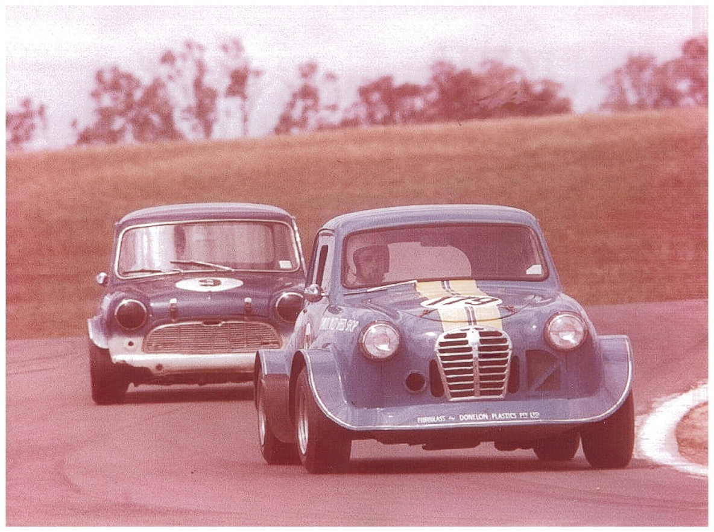
MORE ABOUT AUSTIN A30s
Back in Townsville, Savanna Speedway – a track I like to claim as my doing, was still just starting up and I couldn’t resist the temptation of building a “Saloon Car” to go racing there. It took me over 24 months to get my car [no surprise to see it is another A30] ready to race. Help came from a couple of mates to build the roll cage, workshop space at Jack’s Mullers Tyres, a good BMC engine slightly bigger than the original 1000cc and with engineering from Neil Faggerstrom.
Below are a couple of photos of my A30s at Savanna Speedway
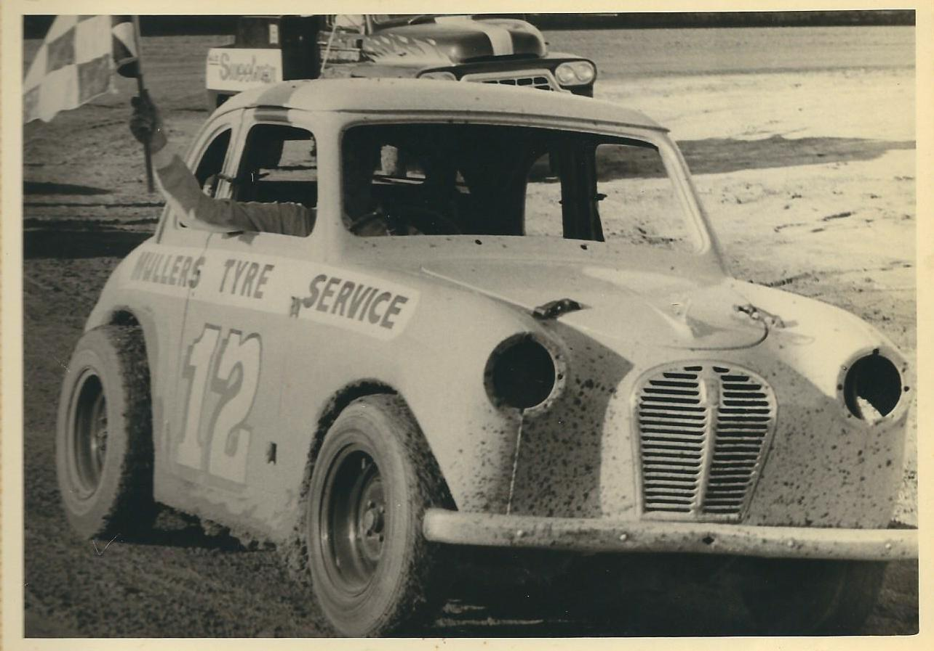
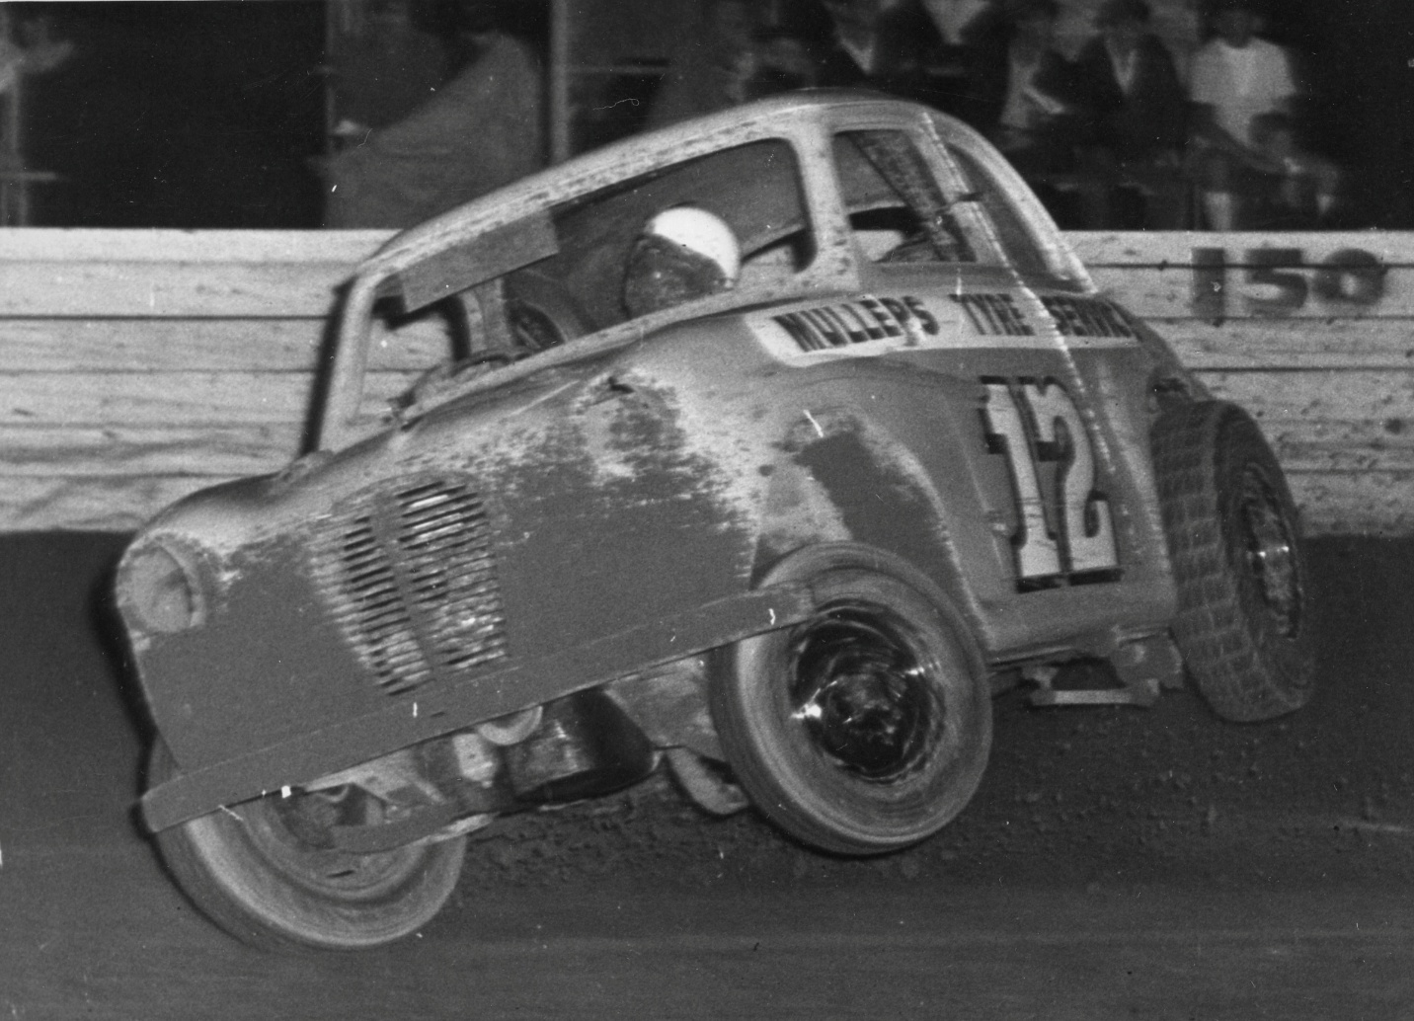

The photo above is my A30 at Savanna Speedway this time driven by a friend, John Millican, who had racing experience in his own modified Mini Cooper S, not at speedway but wanted a drive in my A30. This photo, taken by the track photographer, Ces Rohdes, and made the front cover of several publications. Unfortunately, the car was totally destroyed in the rollover and thankfully John was OK.
So, after that A30s demise - I built a different car for speedway – it was a mini – with help again from Jack’s Mullers Tyres, Neil Faggerstrom and Gracie Signs and the photo below is of me driving it at Savanna.
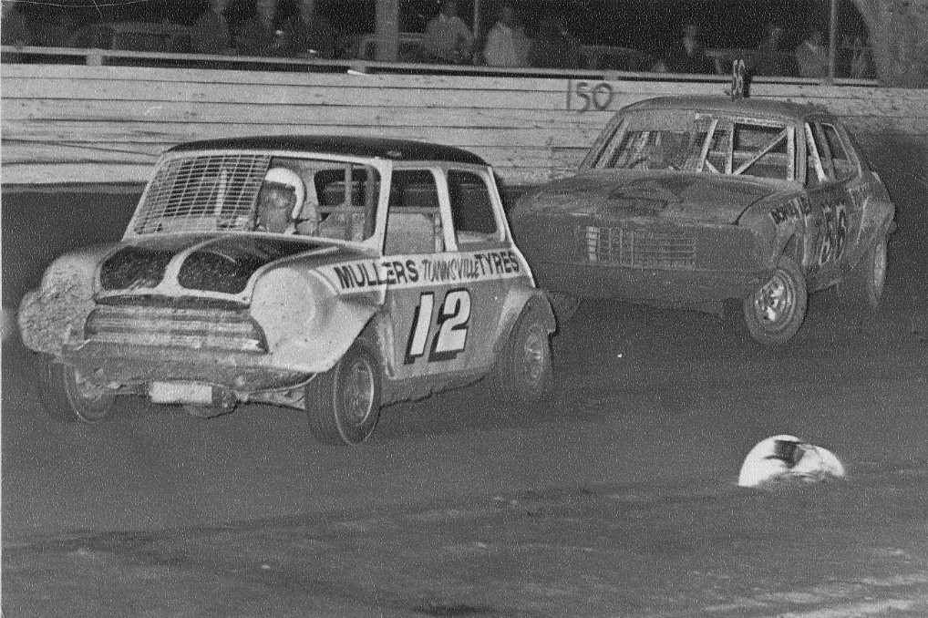
This car’s life was ended at the 1972 Australian Saloon Car Championships at Liverpool in Sydney whilst jostling for 4th outright near the end of the 50-lap final. Whilst lapping a V8 Falcon it clipped the rear of my Mini and was then driven into the fence by the Falcon.

😂 Jokes of the Month
Want to hear a joke about a balloon?
Answer: Oh wait, it just got away from me!
What did the needle say to the balloon?
Answer: I am the king of pop.
What did the needle say to the balloon?
Answer: I am the king of pop.

🏍️ Fun Fact

Hot air balloons, the oldest successful human flight technology (1783), work by heating air inside a nylon "envelope" to create lift, as warmer air is less dense than colder, surrounding air. The first passengers were a sheep, a duck, and a rooster. They are incredibly safe, and can reach staggering altitudes over 68,000 feet.
Champagne Tradition: It is a traditional custom to share a bottle of champagne after landing, dating back to early flights to appease farmers whose land they landed on.

🏆 Sponsor Shoutout
OUR PLATINUM SPONSOR IS:


REMEMBER TO SUPPORT THOSE THAT SUPPORT US.
LET THEM KNOW YOU ARE WITH THE MSCRNQ TO
RECEIVE A DISCOUNT!

