

MARQUE MONTHLY NEWSLETTER

August 2026 Edition
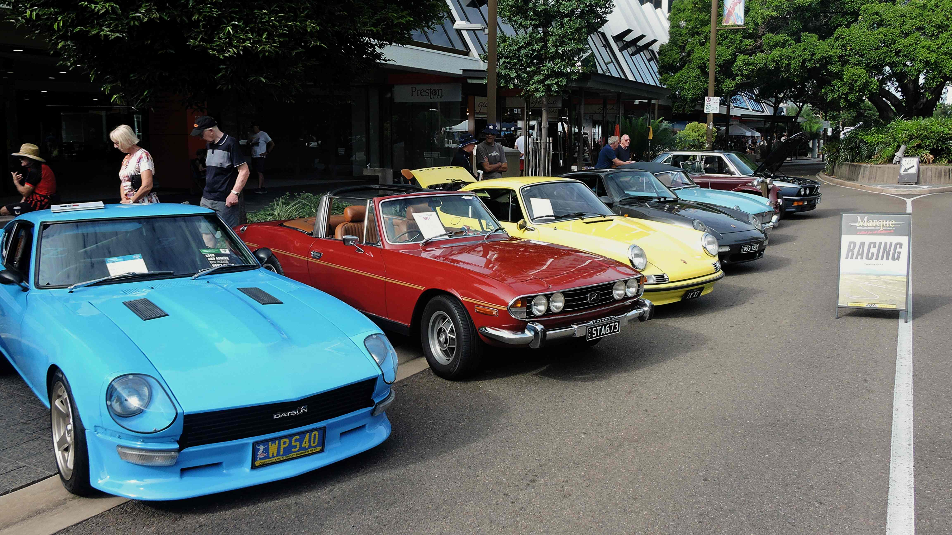

🚗 Event Recaps
Sprint Round 5 – 18th July 2026
I just wanted to give a shout out to our Class winners (great job!!):
Class 2 – Phillip Pyke 1:28.807
Class 3 – Alex Teazis 1:28.607
Class 4 – Rowan Pyke 1:23.256
Class 5 – Bjorn Hawken 1:27.664
Class 6 – Gary Brown 1:16.689
Special Mention Juniors:
Marli Price Class 2 1:33.195
Harlen Price Class 2 1:34.296
Jye Smith Class 2 1:39.207
Mid-Week Drive – 1st July
Following a drive around town ended up at the Commonwealth Hotel – which as usual is a fantastic venue.
Club Dinner/Meeting – 14th July
Dinner was at the Sun Hotel. Great food mixed with great company. Meeting went well.
Mid-Week Drive – 15th July
Had a great drive around town and then went to Banjo’s for morning tea. Always great food and many discussions had regarding cars!
Mid Week Drive – 29th July
Another good drive stopping once again at the Commonwealth Hotel for morning tea

📢 Massive Shout Out
Thanks to everyone who helped at the working bee taking the barriers out to the track. It is greatly appreciated and as the old saying goes – many hands make light work.
Also, a shout out to Silvano for? lending? his car to a fellow racer after the club car broke down. Not many people would have been so generous. It was really, really appreciated.

🗓️ August 2026 Events
- 9 August: Club Drive to Mingela Hotel
- 11 August: Club Meeting – Rodders Clubhouse
- 12 August: Mid-Week Drive - 9:00 AM @ WildCatz Indoor Sports Arena
- 15 August: Sprint Round 6
- 22 August: Club Dinner – Hotel Allen
- 26 August: Mid-Week Drive - 9:00 AM @ WildCatz Indoor Sports Arena
FNQ Chapter: Weekly drives every Wednesday, 9:00 AM @ Tolga Pub.
Sunday Drives: Meet at 9:00 AM @ Sk8way—destination decided on the day. All SIV drivers welcome!
😂 Jokes of the Month
Q: If you have a bee in your hand what do you have in your eye?
A: Beauty. Beauty is in the eye of the bee-holder
Q: What do you call a bee thats returned from the dead?
A: A zombee.
I went to the beekeepers to buy some bees. All the bees had price tags on them except one. It was a freebee.
Q: Where do worker bees go on vacation?
A: Sting-apore.
Q: What do bees do when their friend moves into a new hive?
A: They throw them a house swarming party.
Q: Which is a bee’s favourite sport?
A: Rug-bee.
Q: Who says “zzub zzub zzub”?
A: A bee flying backwards.
Q: What kind of bee hums and drop things?
A: A fumble bee.
Q: Where did Noah keep his bees?
A: In the ark hives.
****Somebody save me from myself and send me some clean jokes!!*****

🏍️ Fun Facts
Australia has more than 10,000 beaches—meaning you could visit a new one every day for over 27 years. It is also the only continent in the world without an active volcano and is home to the world's oldest continuous culture, with Aboriginal history spanning over 65,000 years.
Wild & Ancient Wonders
- Outback Camels: Despite its reputation for native marsupials like kangaroos, Australia actually has a wild camel population of over one million, giving it more camels than Egypt.
- Prehistoric Life: Western Australia is home to some of the world's oldest fossils (Stromatolites) and the Daintree Rainforest, which at an estimated 180 million years old is the oldest continuously surviving tropical rainforest in the world.
- Weird Earthworms: Gippsland, Victoria, is home to the world's longest earthworms, which can grow up to an astonishing 3 meters (10 feet) long.
- Longest Fence: The Dingo Barrier Fence is an incredible 5,600 km long, making it one of the longest man-made structures on Earth and longer than the Great Wall of China.

🏆 Sponsor Shoutout
OUR PLATINUM SPONSOR IS:


REMEMBER TO SUPPORT THOSE THAT SUPPORT US.
LET THEM KNOW YOU ARE WITH THE MSCRNQ TO
RECEIVE A DISCOUNT!

